**A PROPOSED DESIGN AND IMPLEMENTATION OF GYM MANAGEMENT SYSTEM**

### A PROJECT REPORT

***Submitted by***

**Shiva Sharma** (21MCA10004)

**Vinay Vincent** (21MCA10021)

**Rishi Shukla** (21MCA10105)

*in partial fulfillment for the award of the degree of*

## MASTER OF COMPUTER APPLICATION

*in*

### COMPUTER SCIENCE AND ENGINEERING



**SCHOOL OF COMPUTING SCIENCE AND ENGINEERING**

## VIT BHOPAL UNIVERSITY

**KOTHRIKALAN, SEHORE MADHYA PRADESH – 466114**

#### July 2022

**VIT BHOPAL UNIVERSITY, KOTHRIKALAN, SEHORE MADHYA PRADESH – 466114**

## BONAFIDE CERTIFICATE

Certified that this project report titled **“Shiksha Anudan”** is the bonafide work of “**Shiva Sharma (21MCA10004), Vinay Vincent (21MCA10021), Rishi Shukla (21MCA10105)”** who carried out the project work under my supervision. Certified further that to the best of my knowledge the work reported at this time does not form part of any other project/research work based on which a degree or award was conferred on an earlier occasion on this or any other candidate.

##### PROGRAM CHAIR PROJECT GUIDE

Dr. Kanchan Lata Kashyap, Dr. Kanchan Lata Kashyap,

Assistant Professor (Senior) and Assistant Professor (Senior) and Program Chair – MCA Program Chair – MCA

School of Computer Science and Engineering School of Computer Science and Engineering VIT BHOPAL UNIVERSITY VIT BHOPAL UNIVERSITY

The Project Exhibition I Examination is held on 14-07-2022

## ACKNOWLEDGEMENT

First and foremost I would like to thank the Lord Almighty for His presence and immense blessings throughout the project work.

I wish to express my heartfelt gratitude to Dr. Kanchan Lata Kashyap, Head of the Department, School of Computer Science and Engineering for much of her valuable support encouragement in carrying out this work.

I would like to thank my internal guide Dr. Kanchan Lata Kashyap, for continually guiding and actively participating in my project, giving valuable suggestions to complete the project work.

I would like to thank all the technical and teaching staff of the School of Computer Science and Engineering, who extended directly or indirectly all support.

Last, but not least, I am deeply indebted to my parents who have been the greatest support while I worked day and night for the project to make it a success.

## LIST OF FIGURES

|  |  |
| --- | --- |
| **FIGURE NO.** | **TITLE** |
| **1** | **Context level DFD** |
| **2** | **Login** |
| **3** | **Membership** |
| **4** | **Profile** |
| **5** | **Attendance** |
| **6** | **Workout** |
| **7** | **Product** |
| **8** | **Payment** |

**LIST OF TABLES**

|  |  |
| --- | --- |
| **TABLE NO.** | **TITLE** |
| **1** | **Student** |
| **2** | **Donor** |
| **3** | **Transaction** |

### Abstract of the Project Shiksha Anudan:

Shiksha Anudan is a cross platform application which facilitates Student to raise fund for their higher studies by donors who are willing to fund them. Shiksha Anudan bridges the gap between Student and Donor.

Here is our feature list which is continually growing:

* Manage Student
* Manage Donor
* Complete payment statistics
* Verify Details submitted by Donor as well as Student.
* Approve or Block Student based on the document verification.
* Monitor Student donation received.
* Student can see their own statistics and payment history.
* Donor can see their own statistics and payment history

## TABLE OF CONTENTS

|  |  |  |
| --- | --- | --- |
| **CHAPTER NO.** | **TITLE** | **PAGE NO.** |
|  | List of Abbreviations  List of Figures and Graphs | iv v |
| List of Tables | vi |
| Abstract | vii |
| 1 | **CHAPTER-1:** |  |
|  | **PROJECT DESCRIPTION AND OUTLINE** | 1 |
|  | 1.1 Introduction |  |
|  | 1.2 Motivation for the work | . |
|  | 1.3 Problem Statement | . |
|  | 1.4 Objective of the work |  |
|  | 1.5 Summary | . |
|  |  |  |
| 2 | **CHAPTER-2: RELATED WORK INVESTIGATION**   * 1. Introduction   2. Core area of the project   3. Existing Approaches/Methods   4. Pros and cons of the stated Approaches/Methods | 12 |
| 3 | **CHAPTER-3: REQUIREMENT ARTIFACTS**   * 1. Hardware and Software requirements   2. Tools And Technology Used | 16 |

|  |  |  |
| --- | --- | --- |
| 4 | **CHAPTER-4:**  **DESIGN METHODOLOGY AND ITS NOVELTY**   * 1. Methodology and goal   2. Functional modules design and analysis   3. Software Architectural designs   4. Subsystem services   5. User Interface designs   6. Summary | 17 |
| 5 | **CHAPTER-5: TECHNICAL IMPLEMENTATION & ANALYSIS**   * 1. Technical coding and code solutions   2. Working Layout of Forms | 93 |
| 6 | **CHAPTER-6:**  **PROJECT OUTCOME AND APPLICABILITY**   * 1. Outline   2. Significant project outcomes   3. Project applicability on Real-world applications   4. Inference | 95 |
| 7 | **CHAPTER-7: CONCLUSIONS AND RECOMMENDATION**   * 1. Outline   2. Limitation/Constraints of the System   3. Future Enhancements   4. Inference | 98 |

**Introduction**

The aim of creating this project is to help students in getting financial aid for education. This helps them to

pursue their dream without thinking about financial constraints. This app also helps the donors by

providing them an easy and simple platform to donate money and keep track of previous donations.

Admin can track of donations. Admin can block a student or a donor in case of violation of T&C.

Admin will verify the details of students after the have registered.

This application helps Student to track donation they received and also the amount which is remaining. It also allows Donor to see the profile of the student to whom he/she wants to donate the amount. Donor can donate even partially or whole of the amount which is being asked by that respective Student. Admin can track donor donation provided as well as the donation received by the student and remove those students whose donation amount is fully endowed.

##### Entities:

* + Admin
  + Donor
  + Student

## Motivation for the work:

According to a survey conducted by the National Statistical Office (NSO) of the Indian government, one out of every eight students enrolled in a school or college drops out before completing their education and the prominent reason of drop out is the financial condition of the student. There are peoples who want to help those children to want them to get back to their studies but not have enough contacts to them are not having them at all make it lots of harder for the students. So, in order to cater the needs of the students and to help them to restart their education and make significant positive changes in the society, Shiksha Anudan is created. Shiksha Anudan is a non-profitable app which connects donor and the student who require donation.

## Problem Statement:

The currently used donation management system is heavily pruned to data loss due to certain cause’s misplacement of Registers, Destruction of Registers, Unauthorized access to registers etc. which can bring in disastrous consequences. The cost of maintenance of data and records of occurrence of transactions is very high. Retrieving specific data specific to specific requirements is also very tedious in such a system. Retrieving a record can be time consuming as the

Student and Donor must digitally find the corresponding register and keep track of the donation received by the student and the donation which is offered by the Donor respectively.

## Objective of the work:

Ø The main objective of the project is to design and develop a user friendly system. Ø Easy to use and efficient computerized system.

Ø To develop an accurate and flexible system, it will eliminate data redundancy. Ø Computerization can be helpful as means of saving time & money.

Ø To provide better graphical user interface. Ø Less chances of information leakage.

Ø Provides security to data by using login & password

**Related Work Investigation**

##### Introduction:

Our System is having 3 types of users. All the functions which can be performed by these users are listed below:

##### ADMIN:

Admin is the one who manages the whole application and have every access right in the application. Admin can do following things: -

* Admin can login.
* Admin can approve or block Student.
* Admin can remove Student based on the detail submitted by him/her at the time of registration.
* Admin can remove Student from the list of Student which are available for donation when the Student asked value has been achieved.
* Admin can remove Donor as well, after detecting some suspicious activity done by him/her.
* Admin can manage the Student and Donor.
* Admin can manage payments.

##### Donor:

Donor is like one of the types of customers of Shiksha Anudan. Things Donor can access on our application is the list of Student which are available for the particular slab of donation, view Student profile etc.

Donor can do following things: -

* Donor can login.
* Donor can manage his/her profile.
* Donor can search Student which are available for Donation.
* Make donation to the respective Student in full or partially.
* Donor can view or track donation of his/her own.
* See Student profile. His/her educational qualification and SOP etc.

##### Student:

Students are important aspect of the application. These are the ones who are on the application for the fund. Student can do following things: -

* Student can login.
* Student can manage his/her own profile.
* Student can view donation received by him/her.
* Student update SOP.
* Student update contact details.

## Existing system

* Donor are flooded with the people asking for donation that makes difficult for the Donor to find Student asking for donation.
* Student are compelled to register in the applications which are not centered around educational donation.
* Nobody keeps track of the Donation made and donation received by the donor and Student respectively.

## Proposed system

* In this system student and donor can register (this will be approved by admin).
* In this system student will be able to keep track of their progress (donation received).
* In this system donor can see all their previous donations.
* This app provides an easy to use interface and payment gateway.

## Pros and cons of the stated Approaches/Methods:

### Existing System:

In the existing system the work is done only manually but in proposed system we have to computerize the work using this application

##### Cons of Existing System:

* Lack of security of data
* More manpower
* Time consuming
* Consumes large volume of pare work
* Needs manual calculations

### Proposed System:

The aim of proposed system is to develop a system of improved facilities. The proposed system can overcome all the limitations of the existing system. The system provides proper security and reduces the manual work.

##### Pros of proposed System:

* Security of data.
* Ensures data accuracy
* Minimize manual data entry
* Minimum time needed for the various processing
* Greater efficiency
* Better service
* User friendliness and interactive
* Minimum time required

### REQUIREMENT ARTIFACTS

* 1. **HARDWARE REQUIREMENTS**
     + CPU Type : Pentium dual or above
     + RAM : 1 GB or above
     + Display Type : VGA
     + Hard Disk Drive : 20 GB or greater
     + Printer : Any Printer Supported by the OS

### SOFTWARE REQUIREMENTS

* + - Operating System : WINDOWS 7 or higher
    - Front End : Flutter
    - Back End : Firebase

### Tools and Technology Used

* + - Frontend: Flutter
    - Backend: Firebase
    - Other Tools: Microsoft PowerPoint 2019, EDraw max 9.0, Microsoft Visio 2016 and Microsoft Word 2019

### DESIGN METHODOLOGY AND ITS NOVELTY

**4.1 Entity Relationship Diagram**

E-R Model is a popular high level conceptual data model. This model and its variations are frequently used for the conceptual design of database application and many database design tools employ its concept.

A database that confirms to an E-R diagram can be represented by a collection of tables in the relational system. The mapping of E-R diagram to the entities are:

* Attributes
* Relations
  + Many-to-many
  + Many-to-one
  + One-to-many
  + One-to-one
* Weak entities
* Sub-type and super-type

The entities and their relationships between them are shown using the following conventions.

* An entity is shown in rectangle.
* A diamond represents the relationship among number of entities.

## Data Flow Diagram

A data flow diagram (DFD) maps out the flow of information for any process or system. It uses defined symbols like rectangles, circles and arrows, plus short text labels, to show data inputs, outputs, storage points and the routes between each destination. Data flowcharts can range from simple, even hand-drawn process overviews, to in-depth, multi-level DFDs that dig progressively deeper into how the data is handled. They can be used to analyze an existing system or model a new one. Like all the best diagrams and charts, a DFD can often visually “say” things that would be hard to explain in words, and they work for both technical and nontechnical audiences, from developer to CEO. That’s why DFDs remain so popular after all these years. While they work well for data flow software and systems, they are less applicable nowadays to visualizing interactive, real-time, or database-oriented software or systems.

##### Context Level:

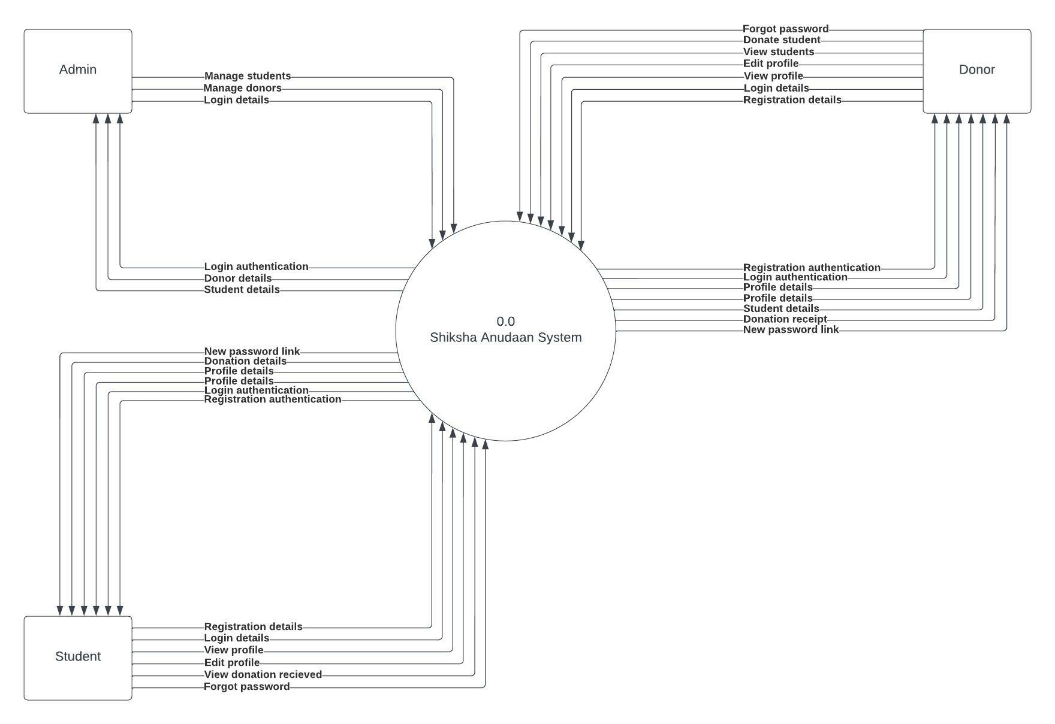

**Level 1:**

Level 1

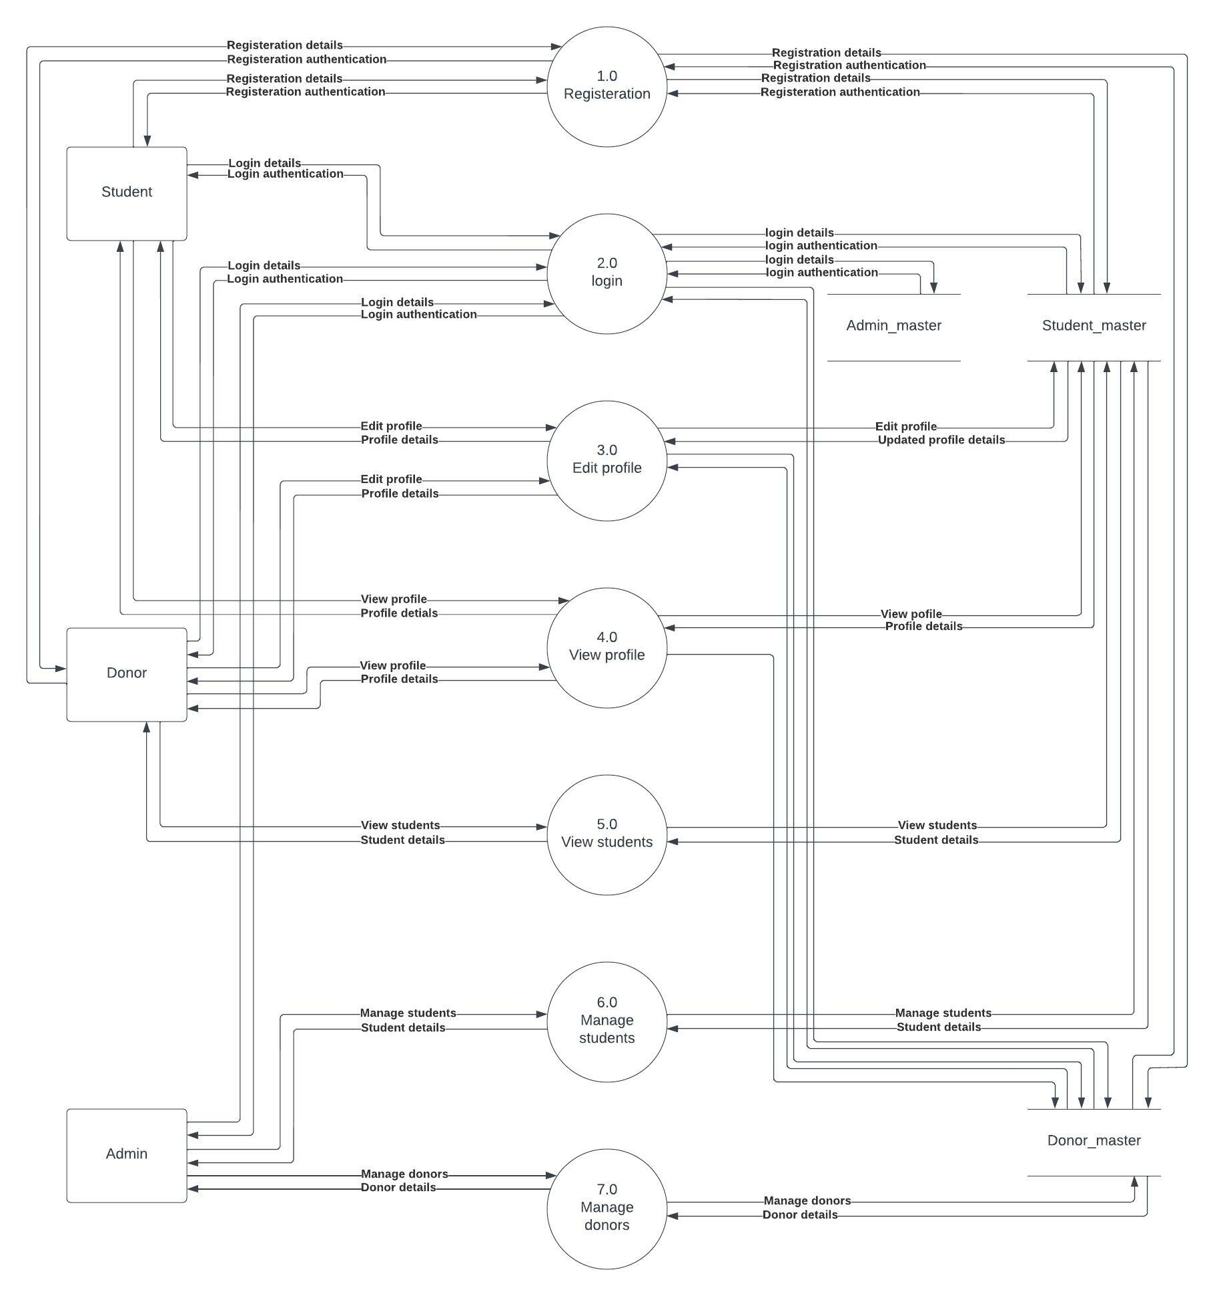

## Data Dictionary

**Database Technology: Firebase**

Cloud Firestore is a cloud-hosted, NoSQL database that any Apple, Android, and web apps can access directly via native SDKs.

1. **User Authentication**

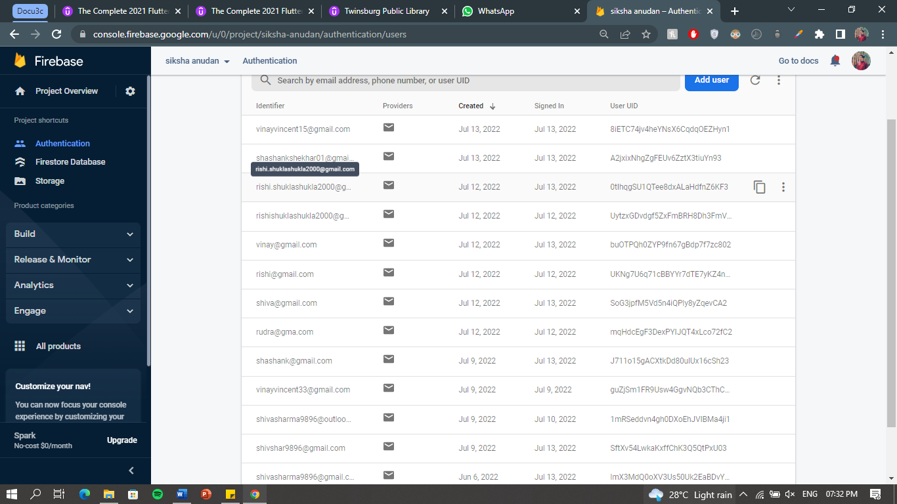

1. **Table Name:** Donor_master

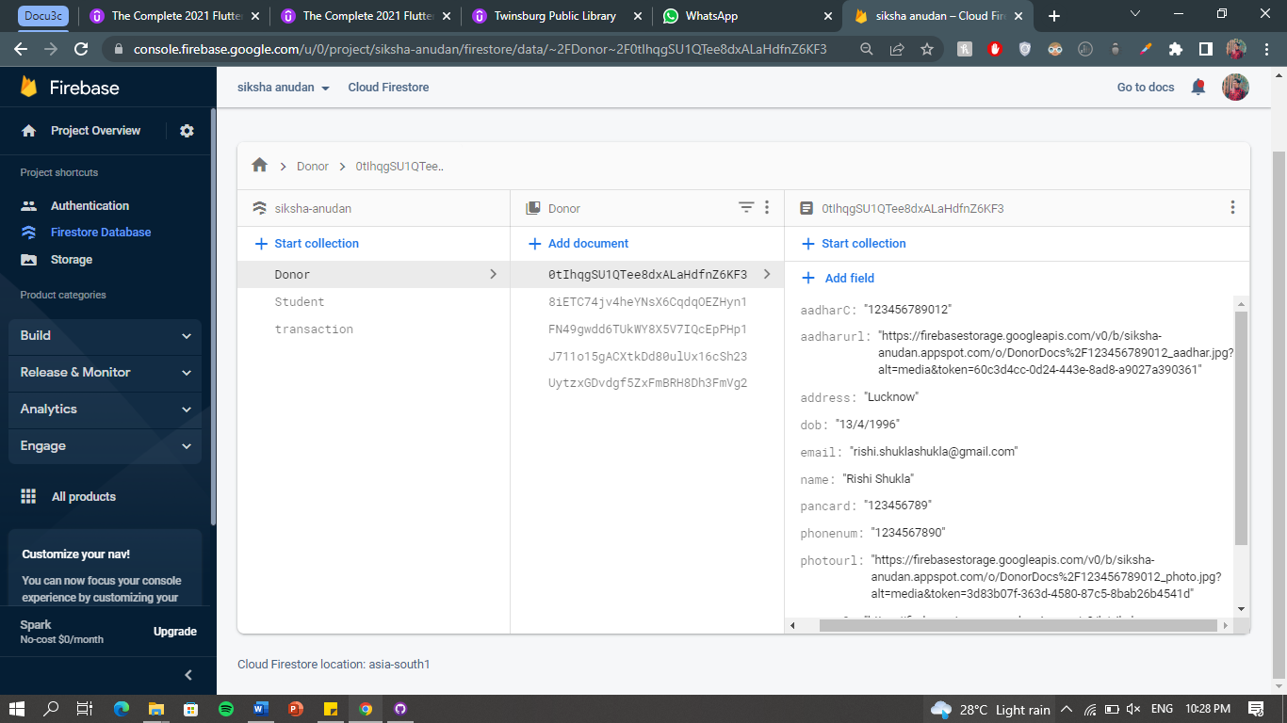

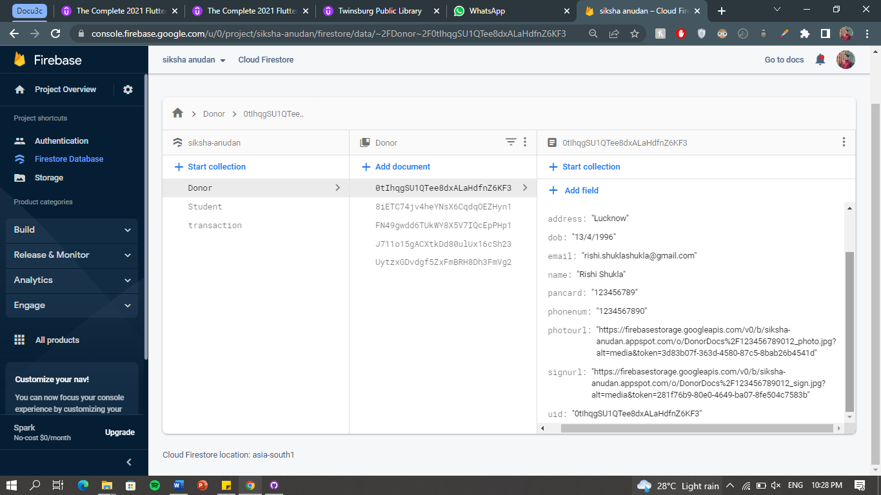

1. **Table Name:** Student_master

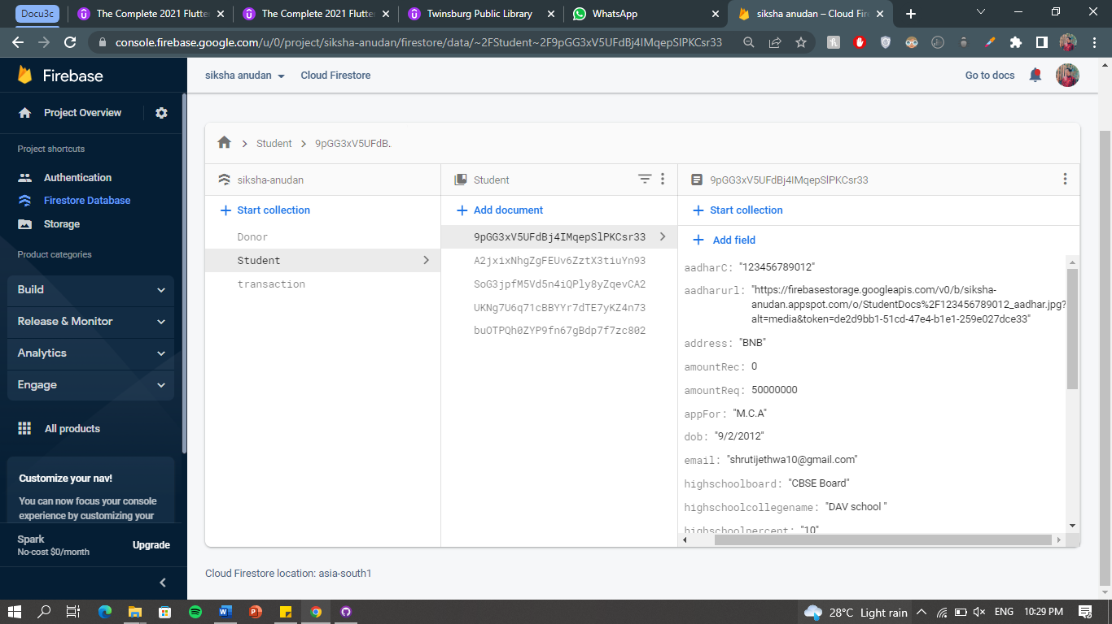

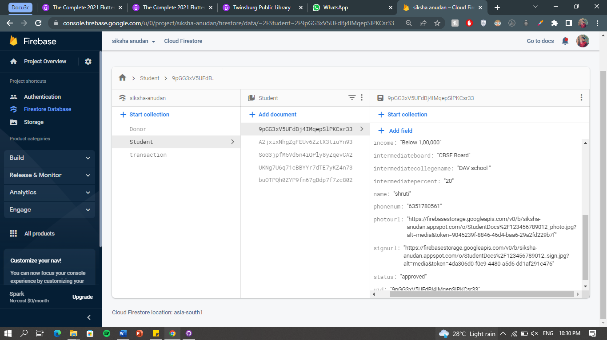

1. **Table Name:** Transaction_master

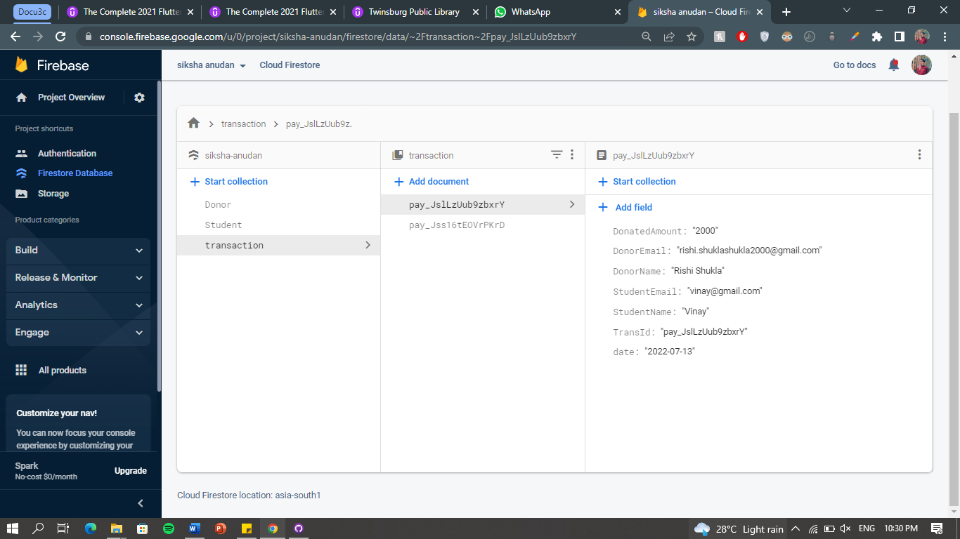

**Storage:**

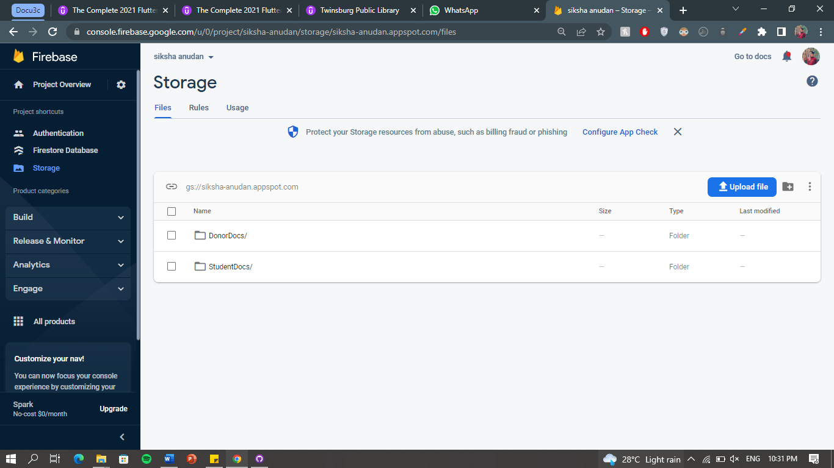

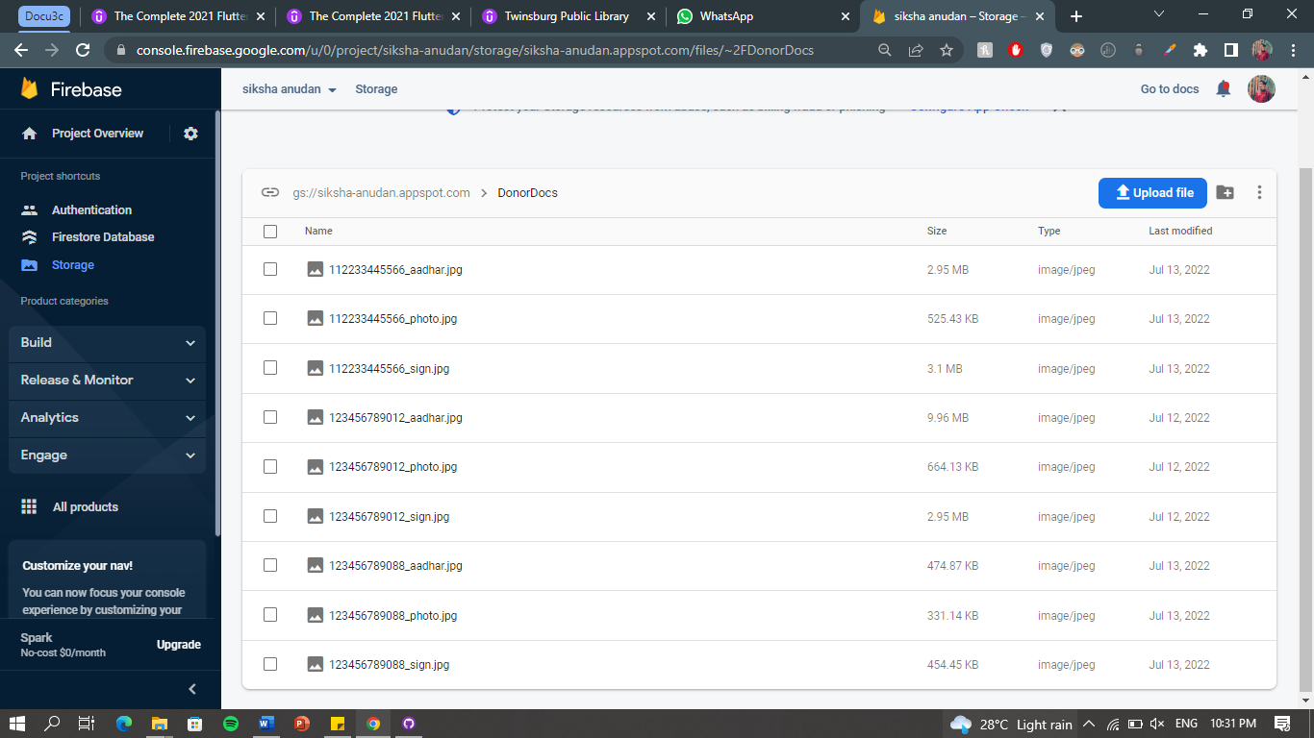

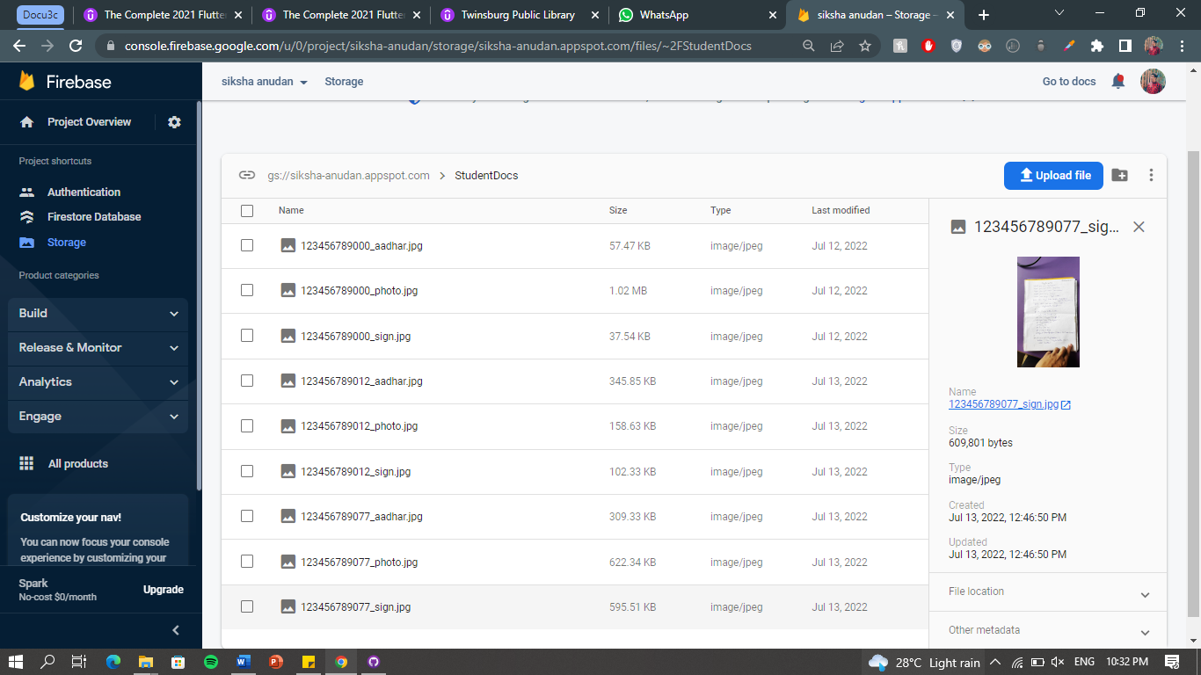

**SCREEN LAYOUTS**

## ADMIN SIDE:

**Admin Login Page:**

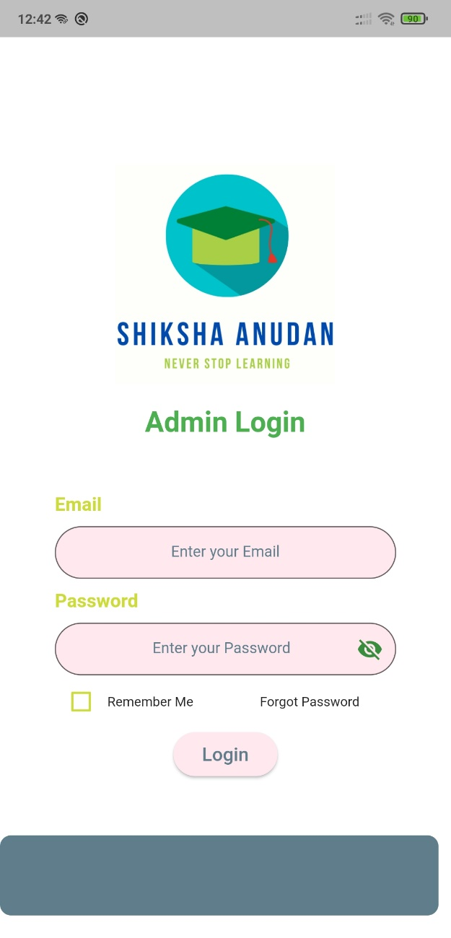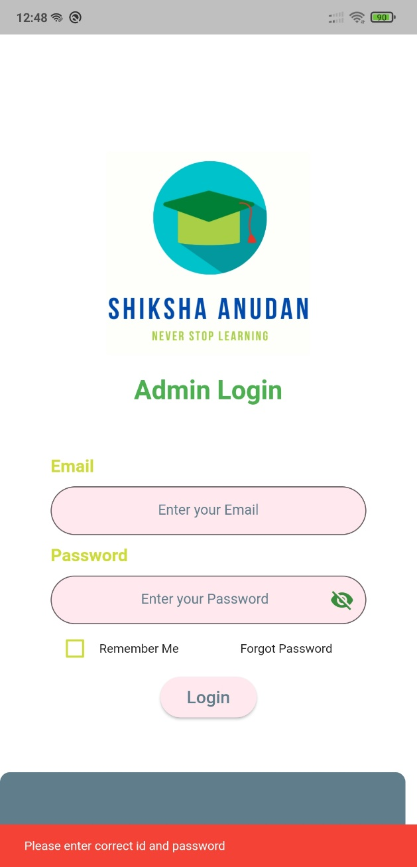

**Donor Home Page:**

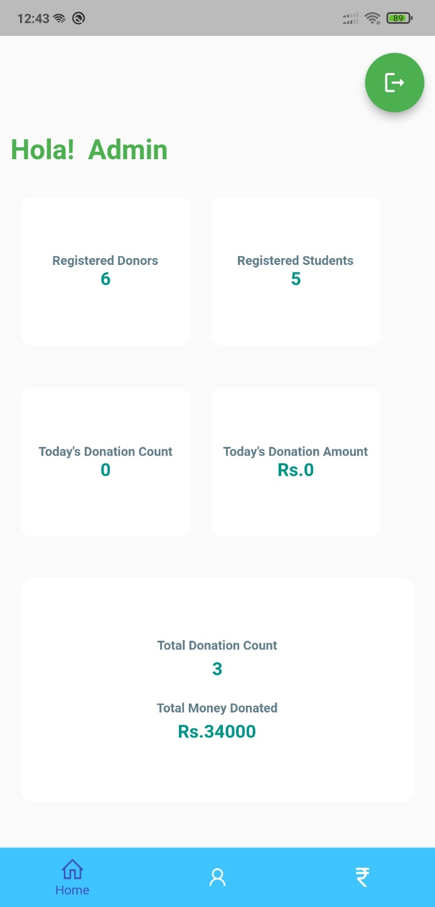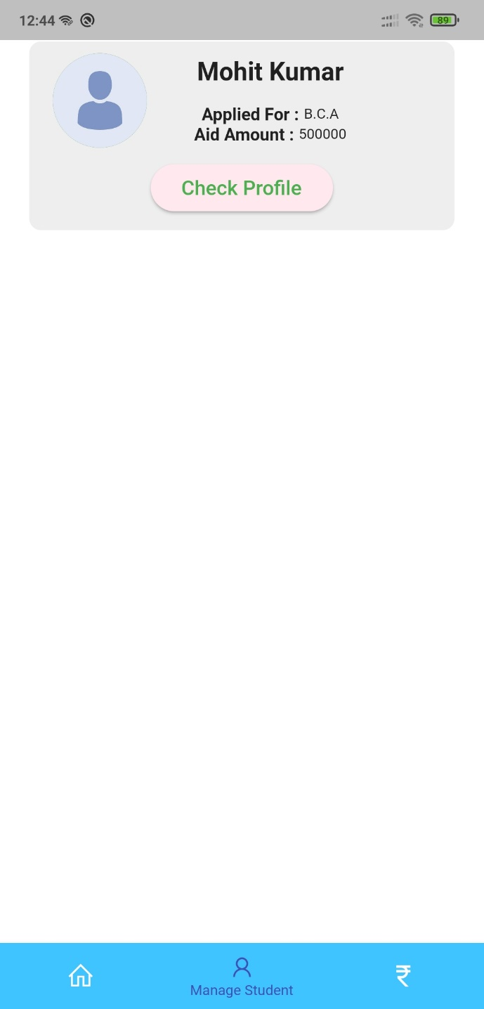

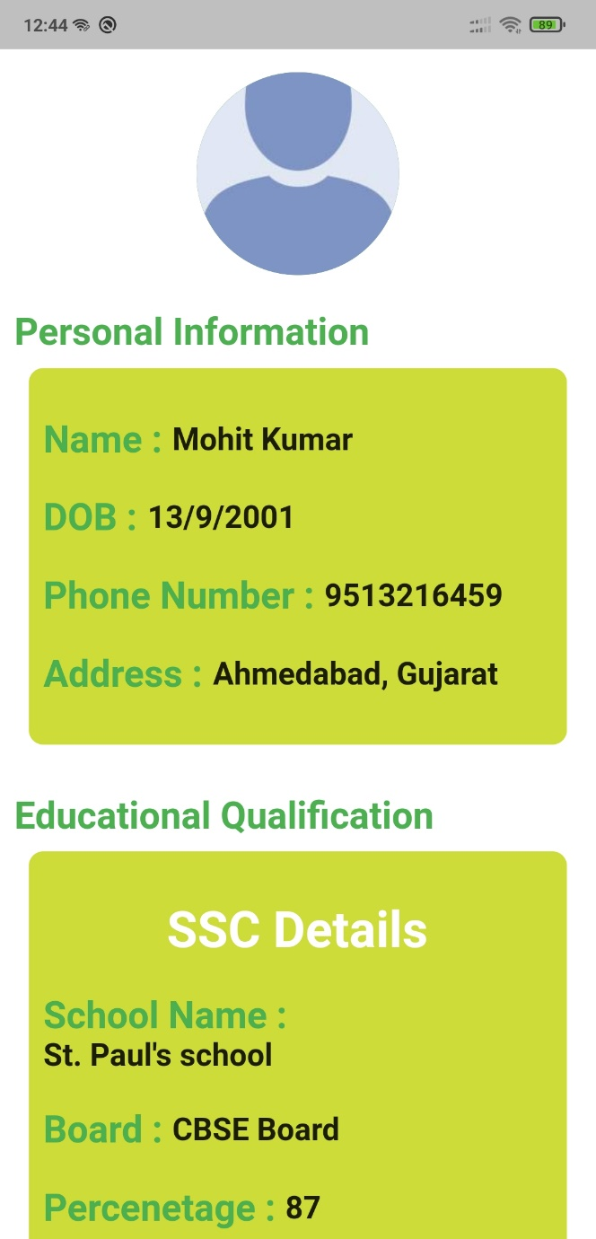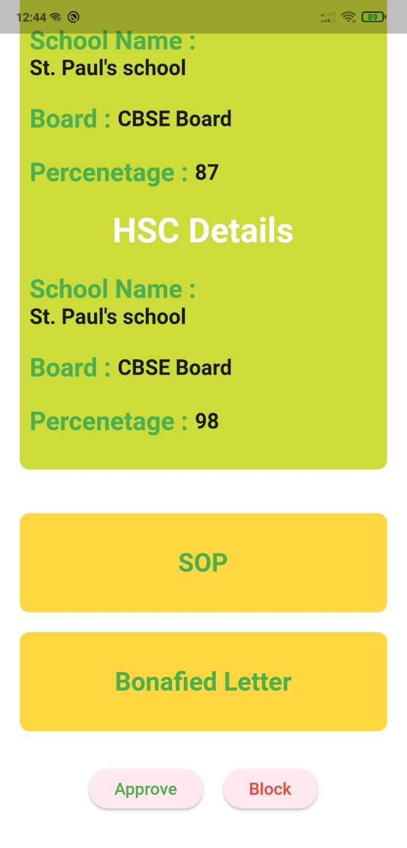

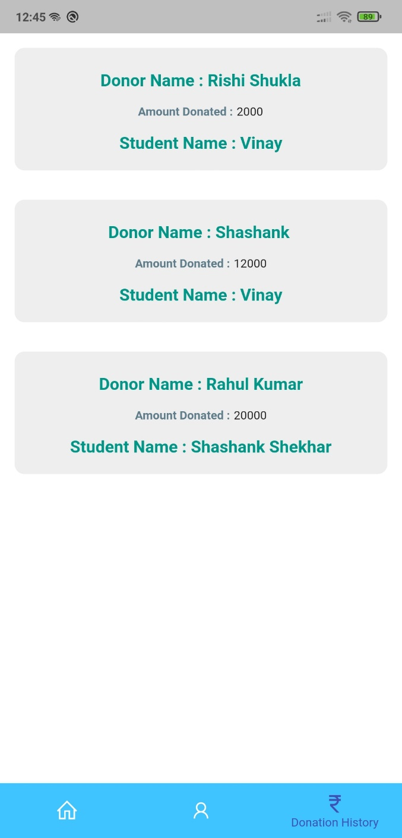

**Donor Forgot Password:**

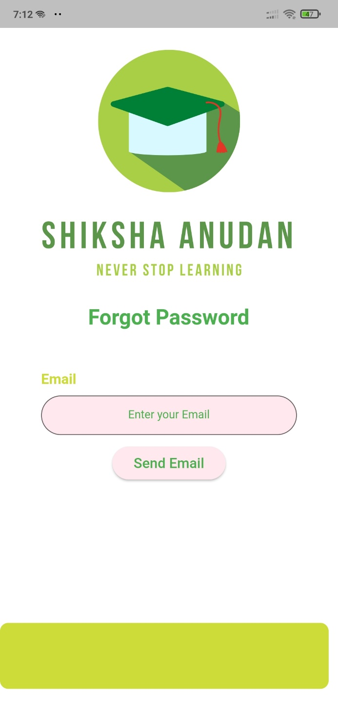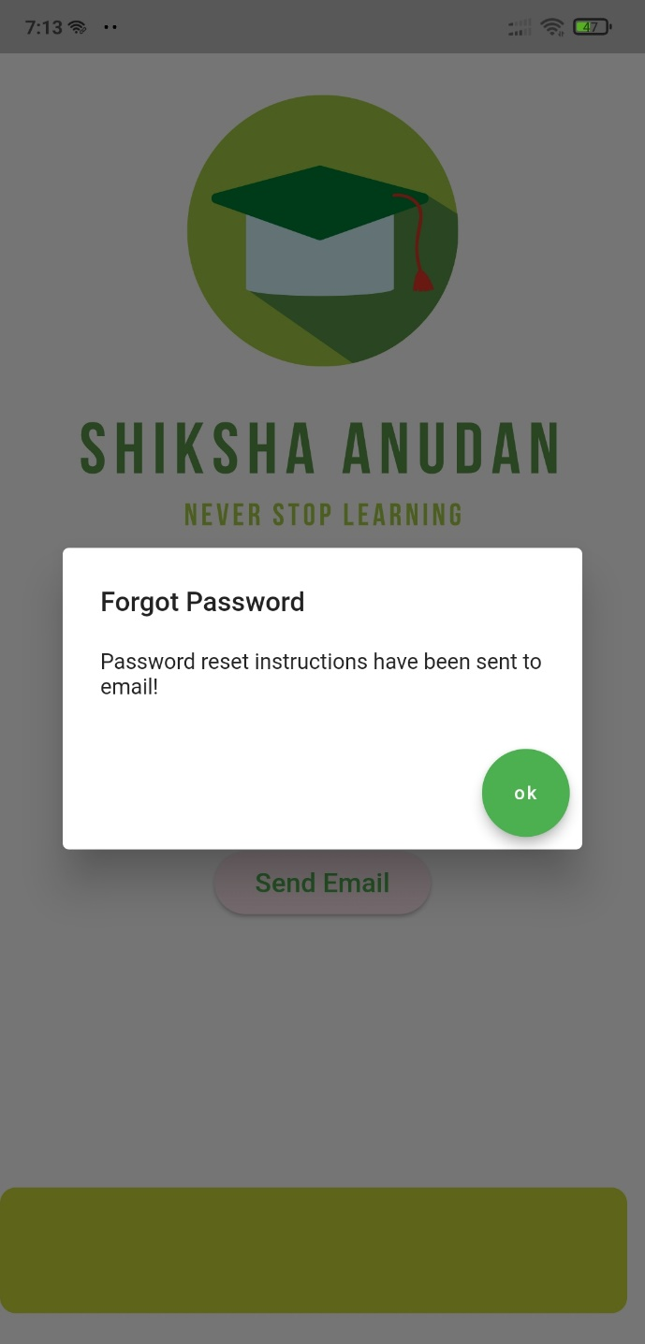

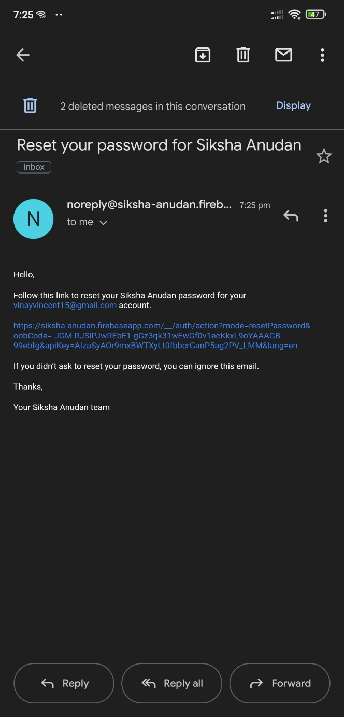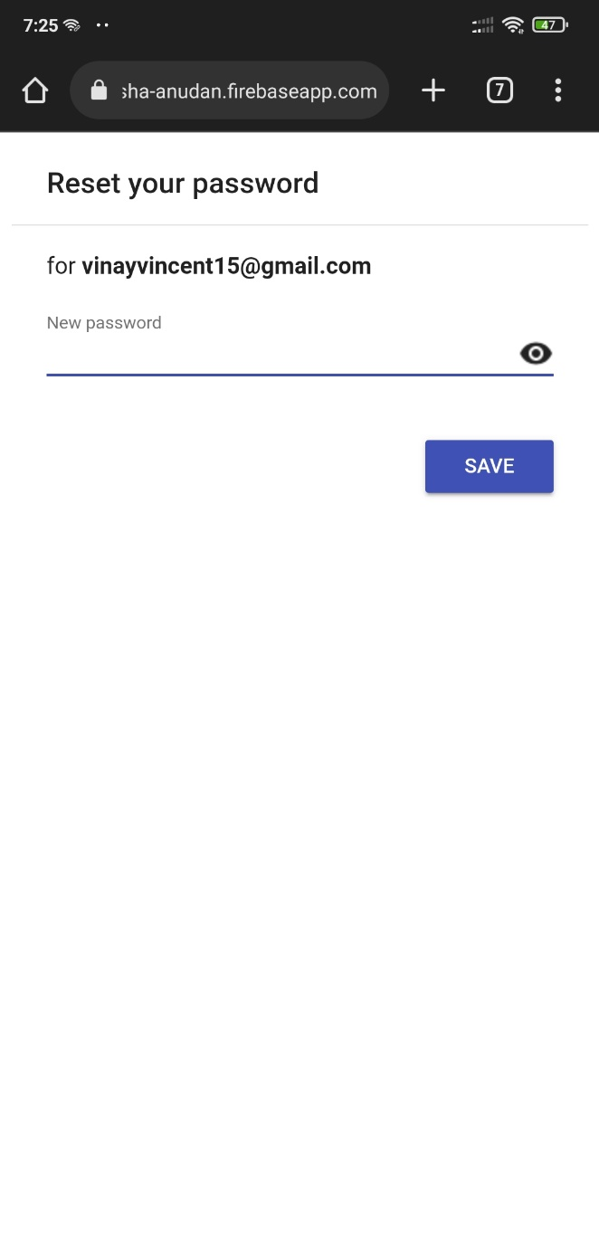

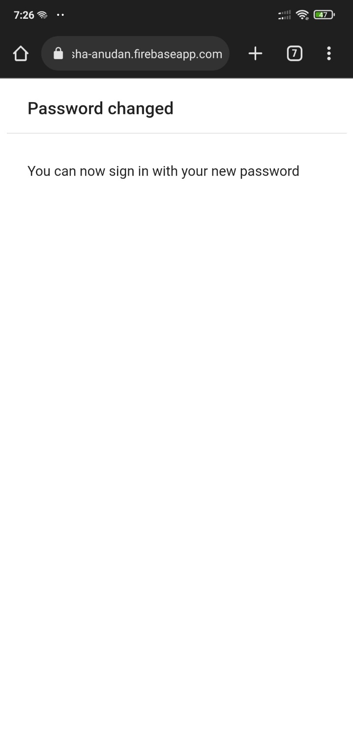

* 1. **DONOR SIDE:**

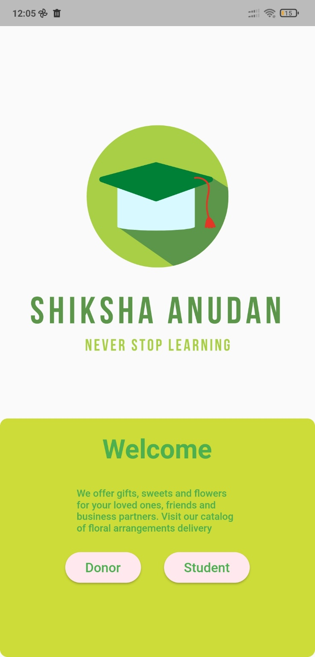

**Donor Login Page:**

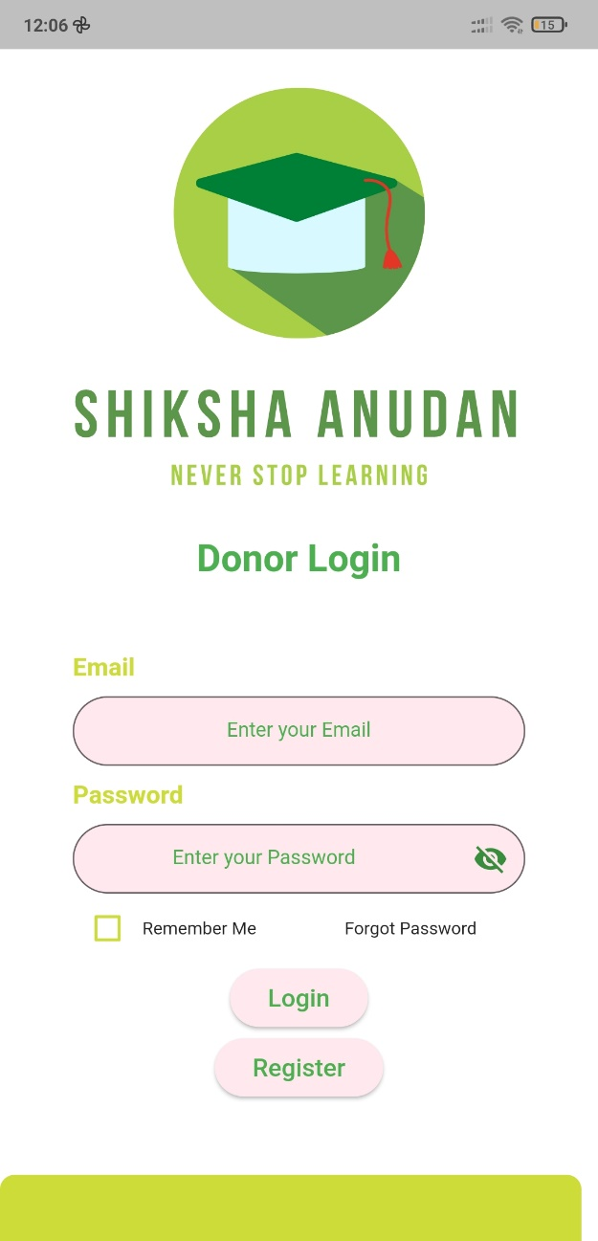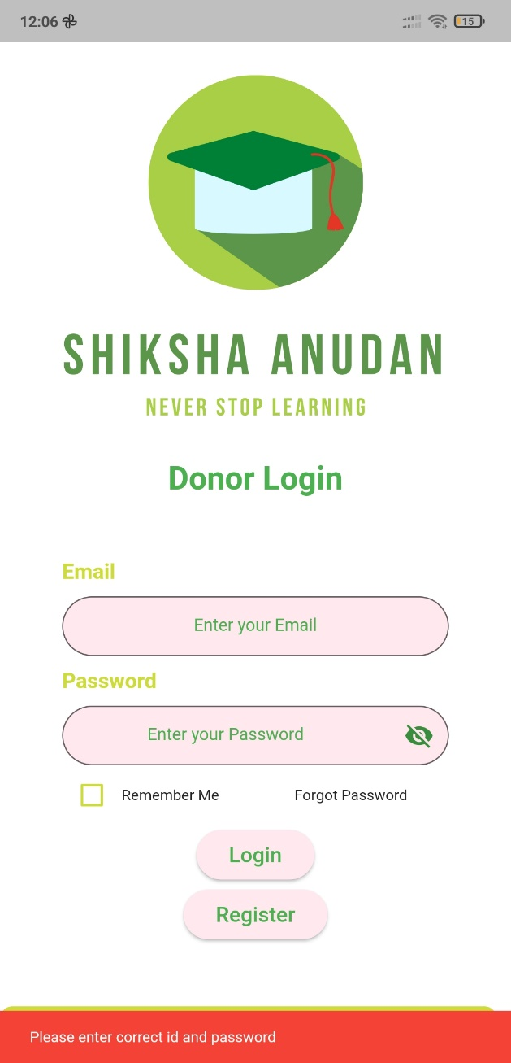

**Donor Registration Page:**

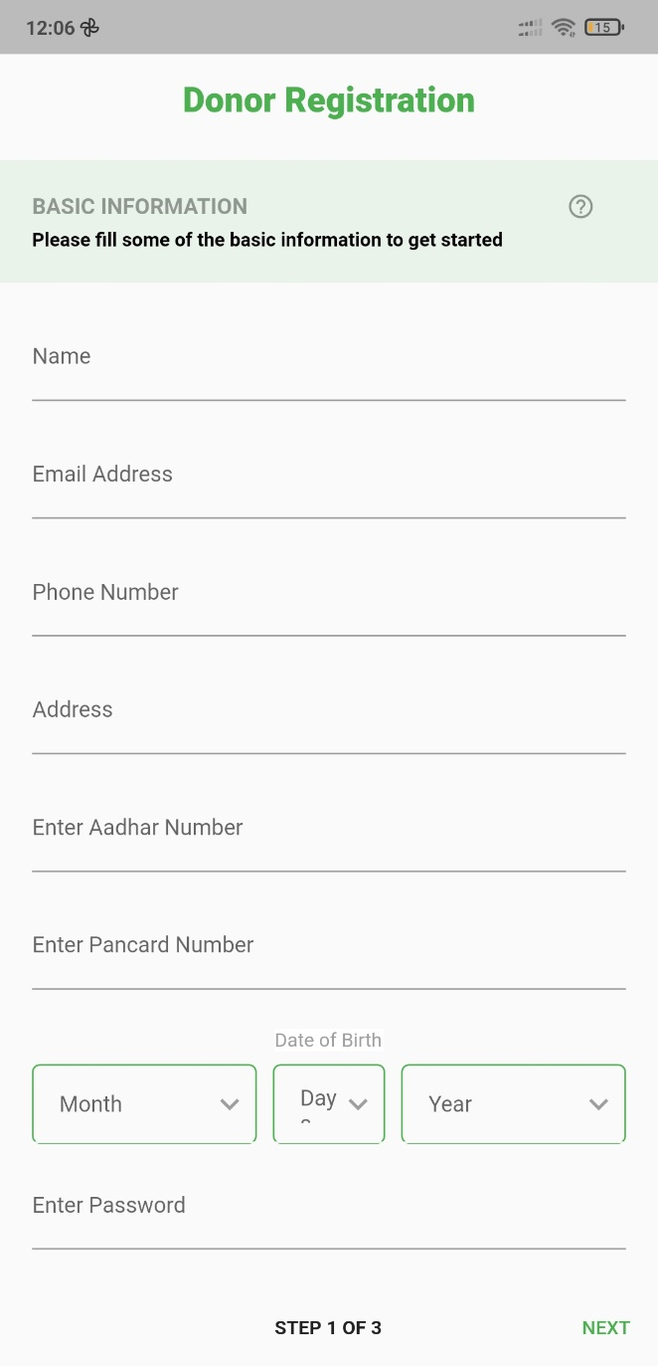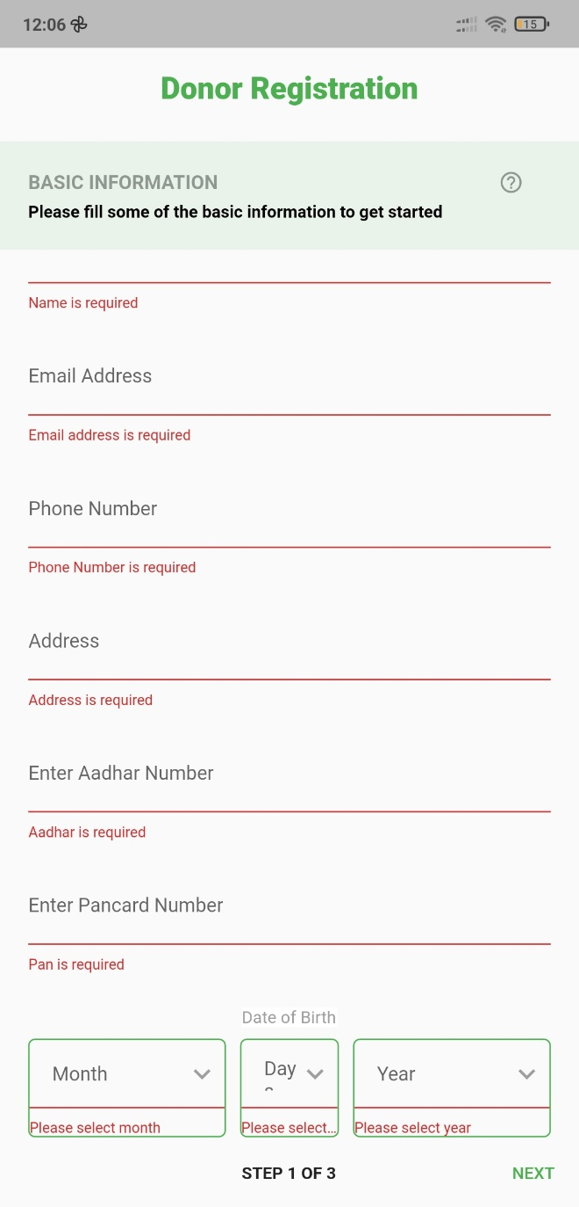

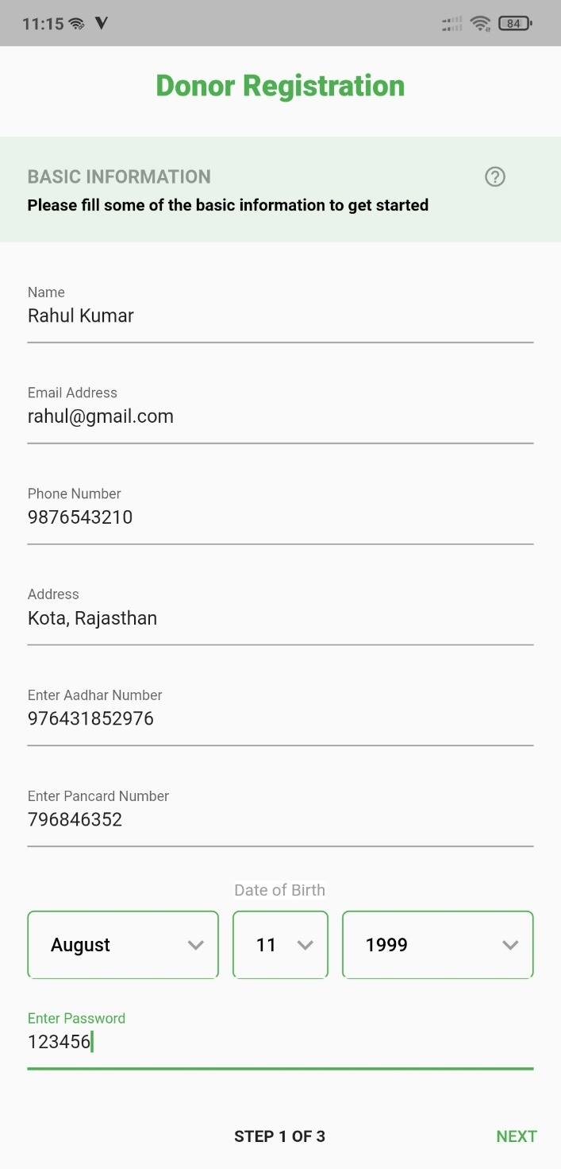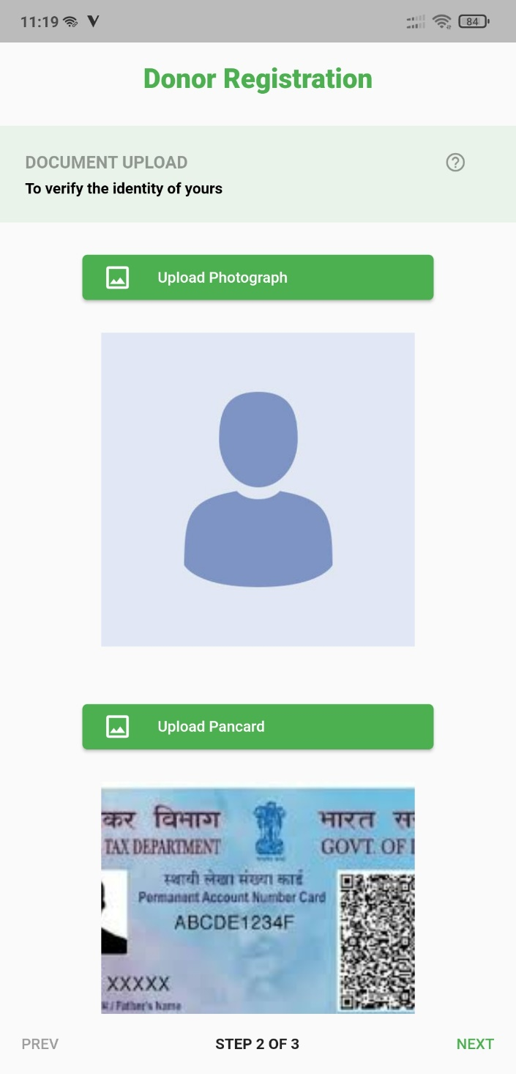

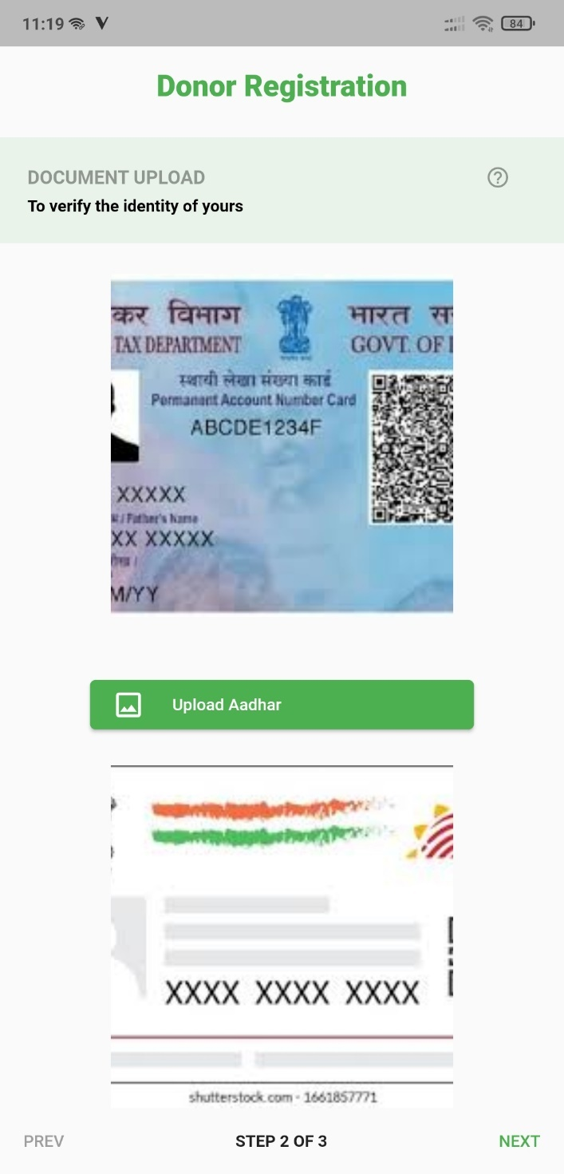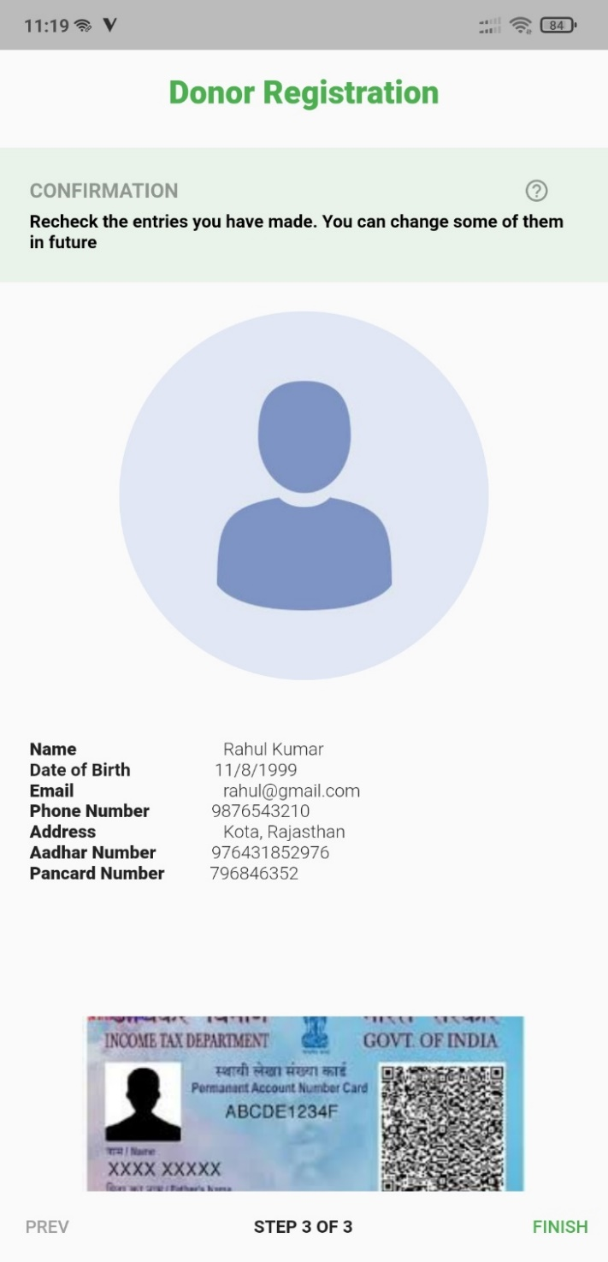

**Donor Home Page:**

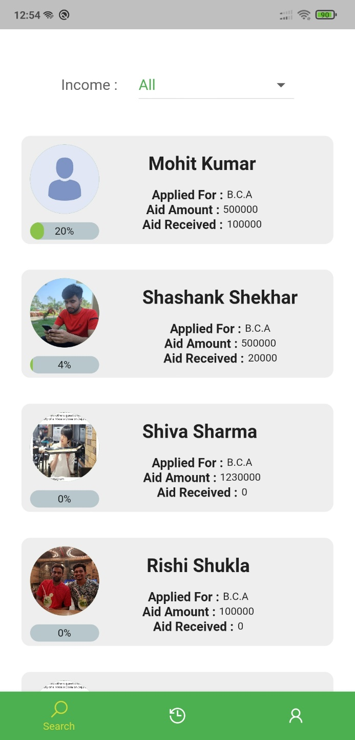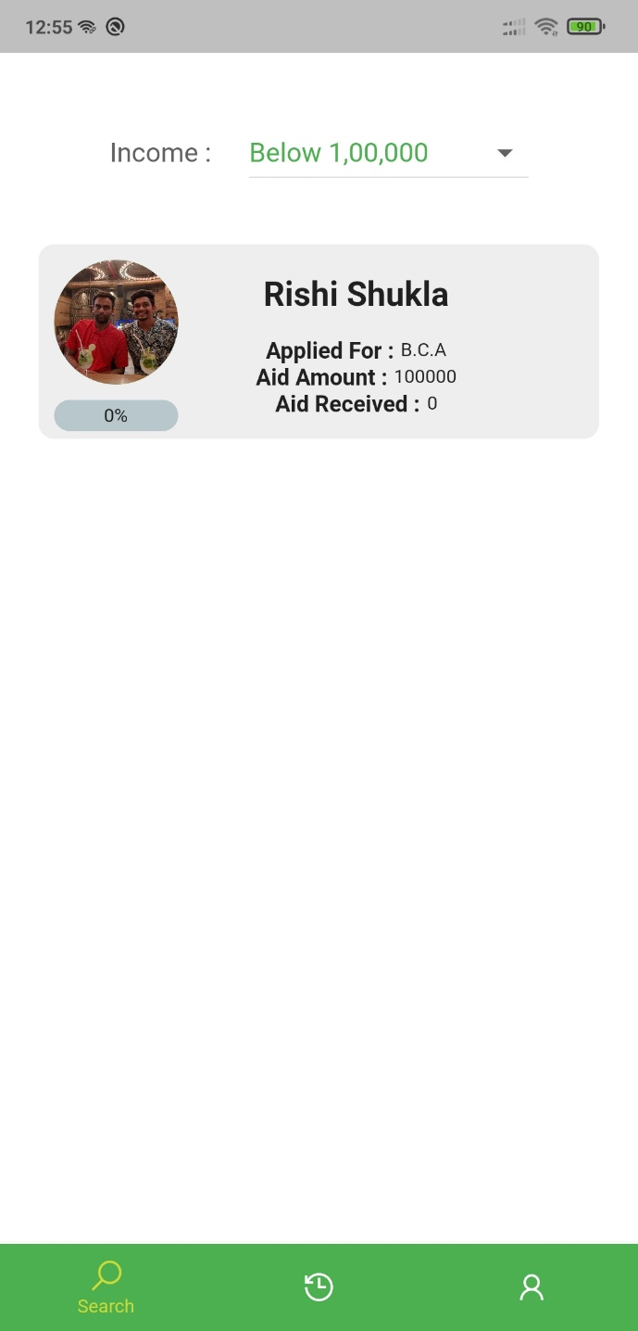

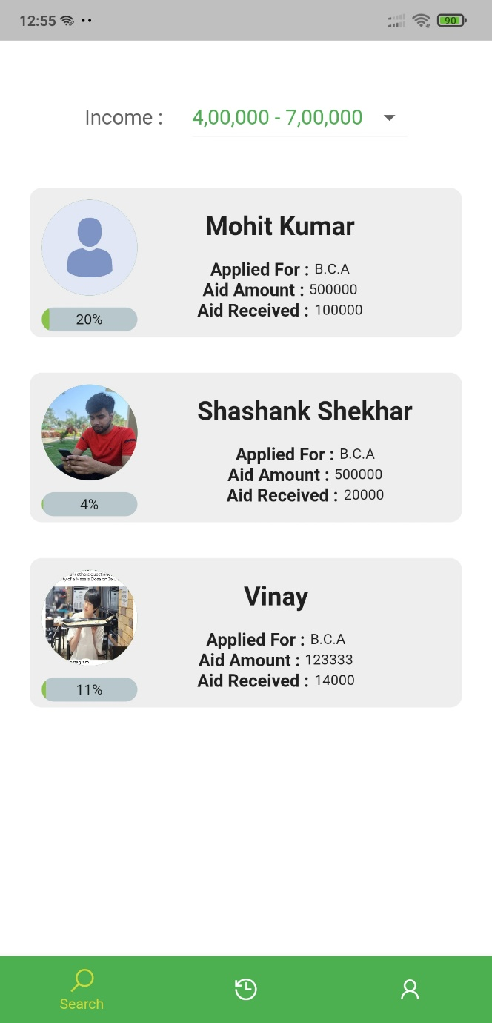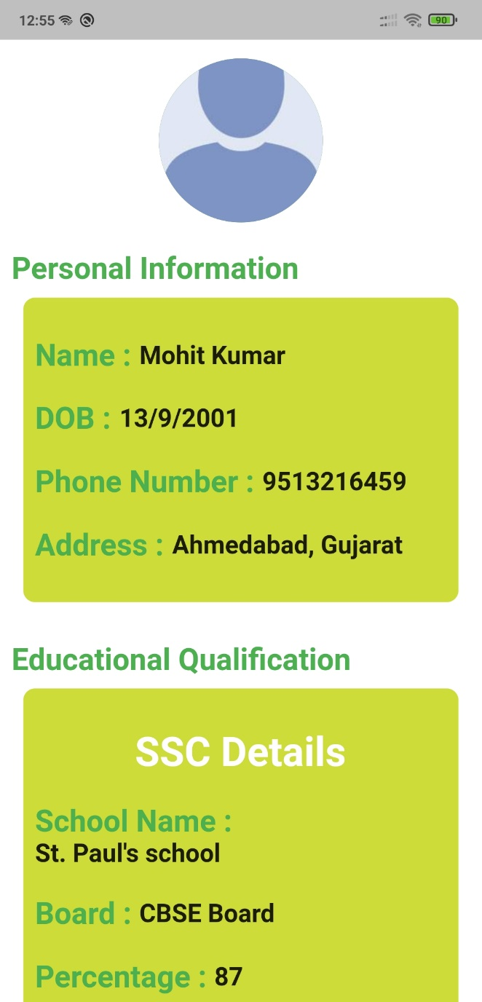

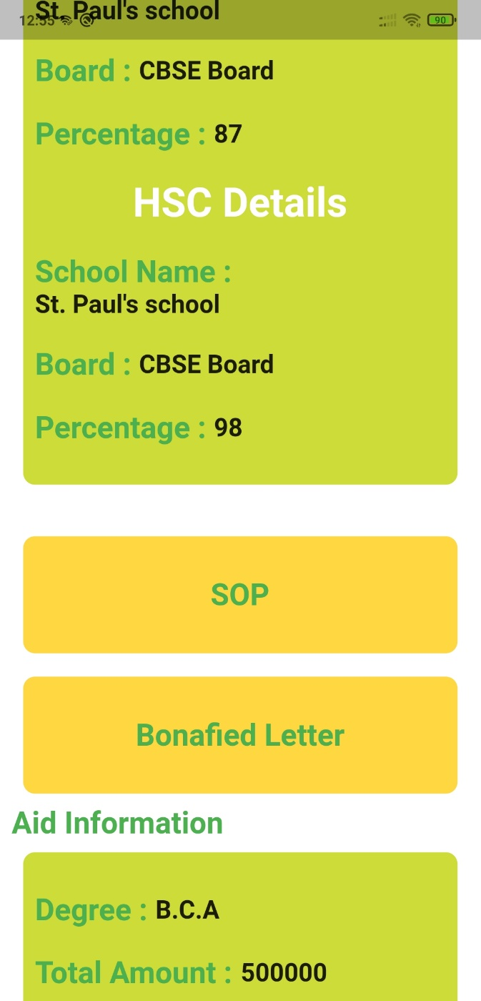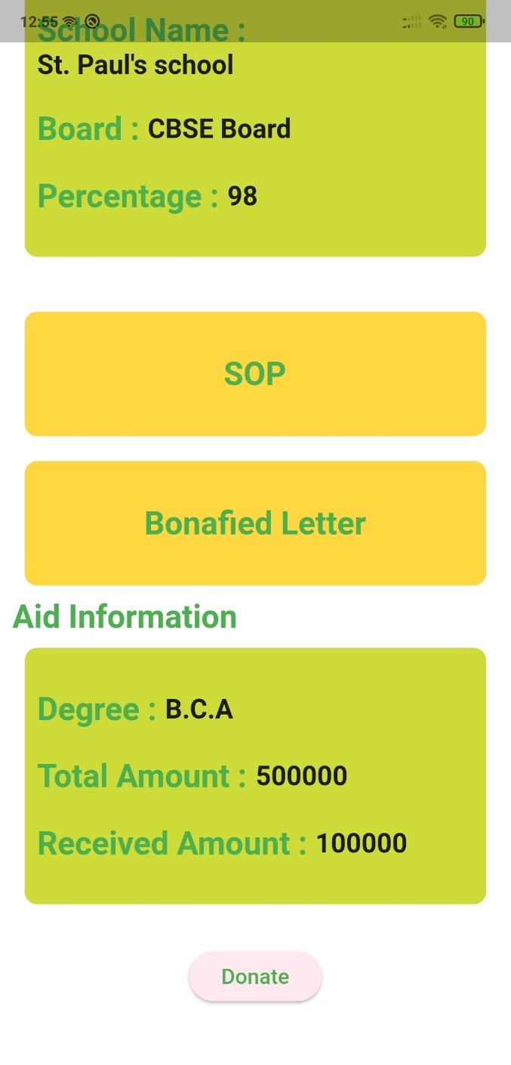

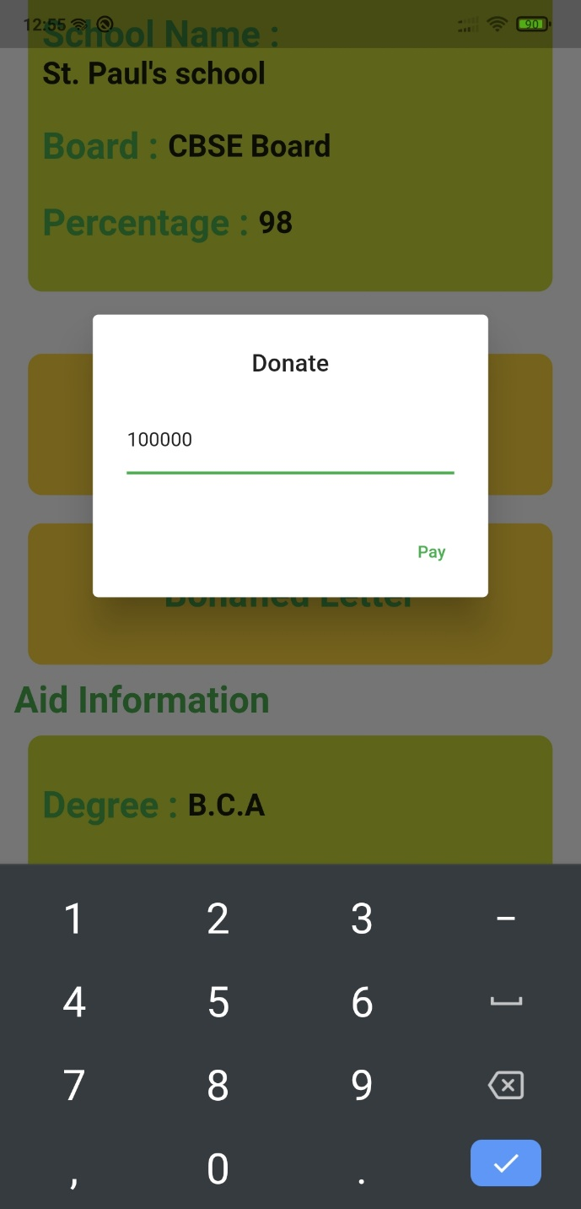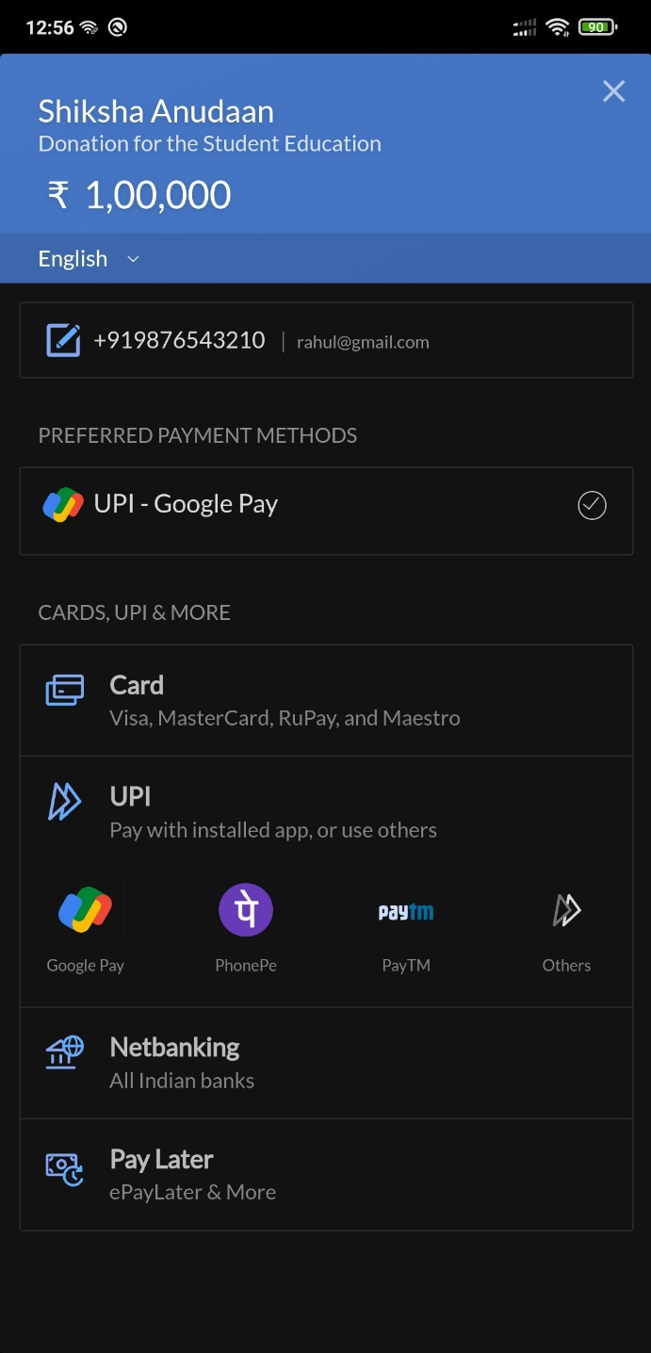

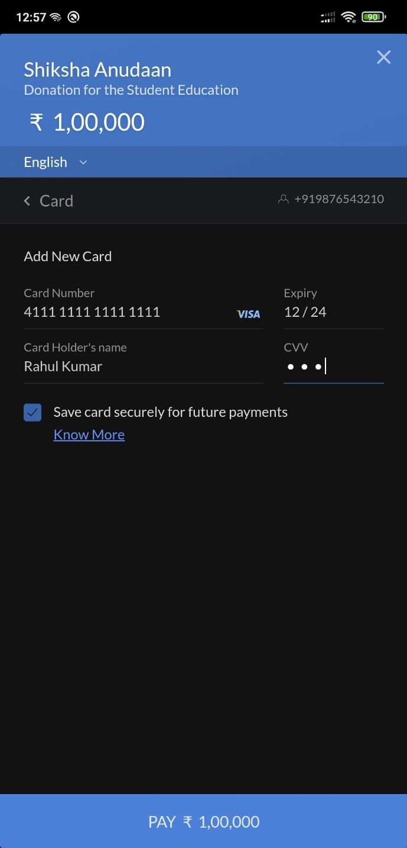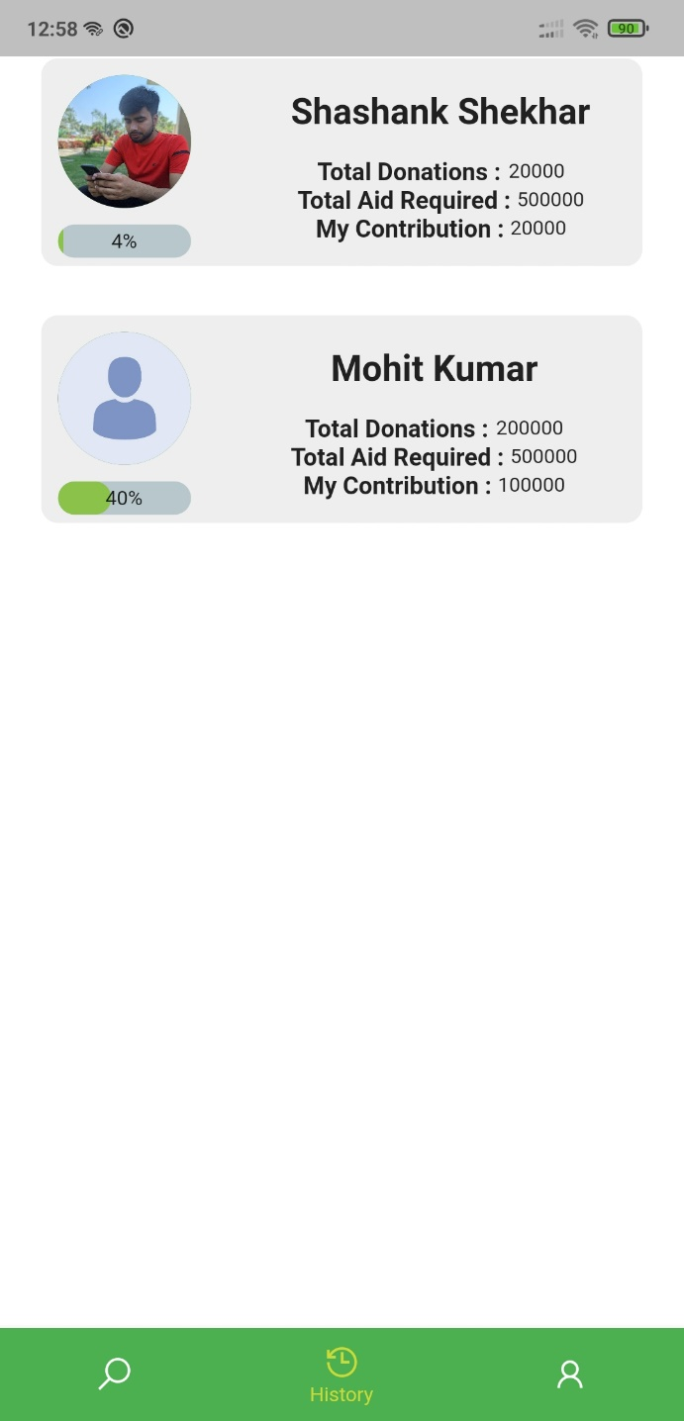

**Donor Profile:**

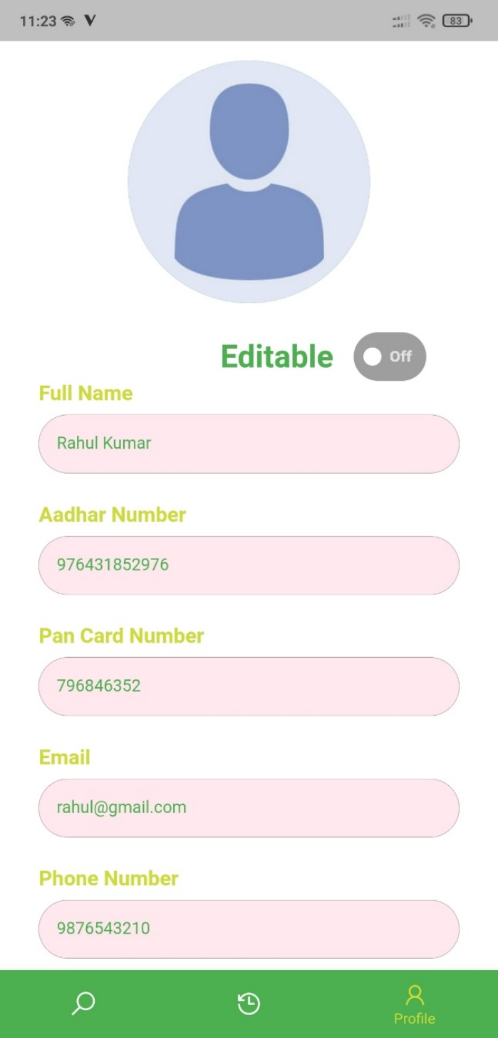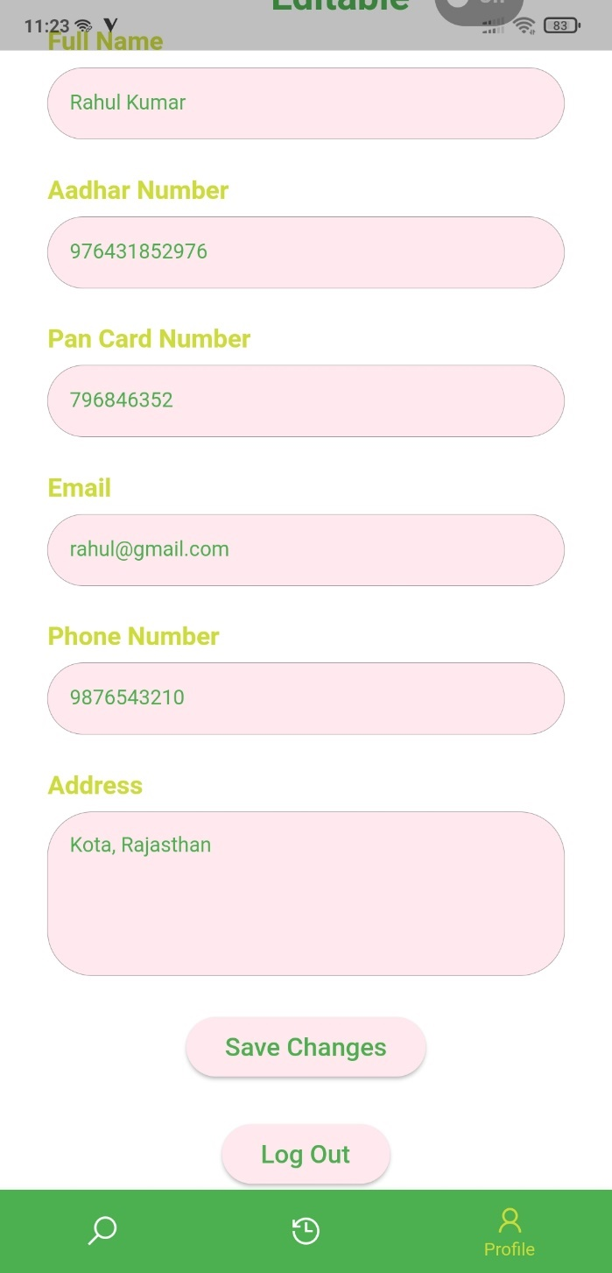

**Donor Forgot Password:**







### STUDENT SIDE:



**Student Login Page:**

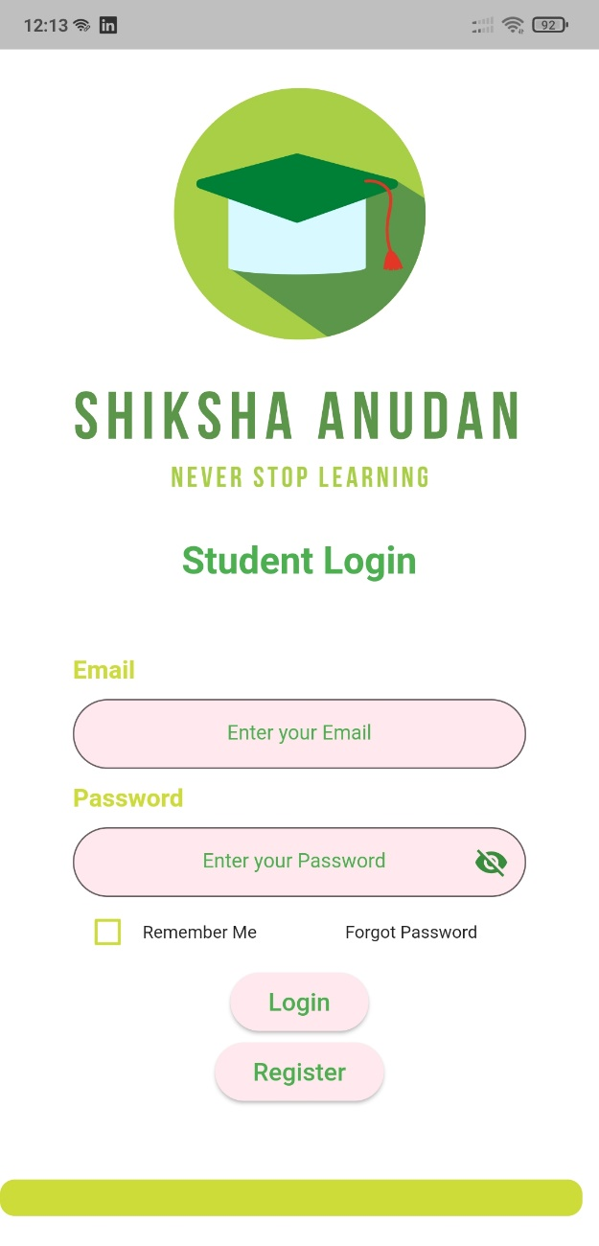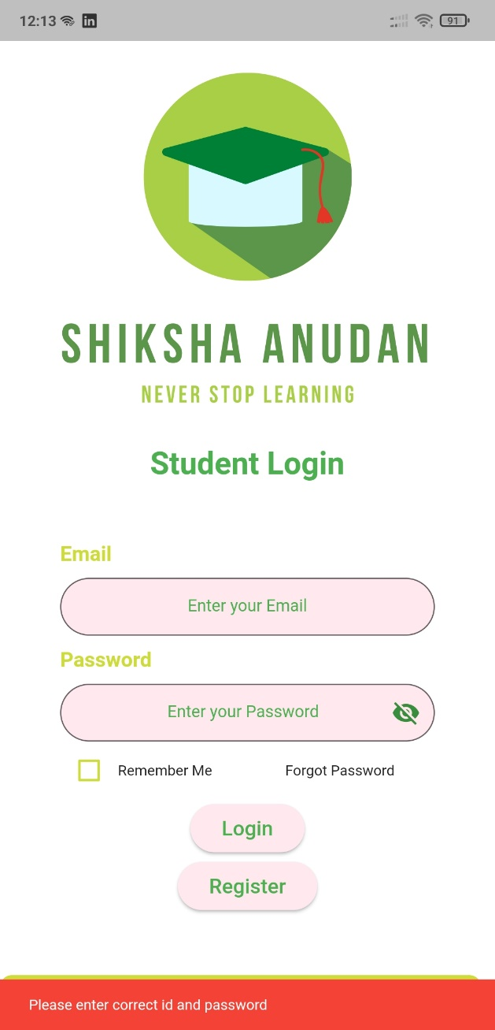

**Student Registration Page:**

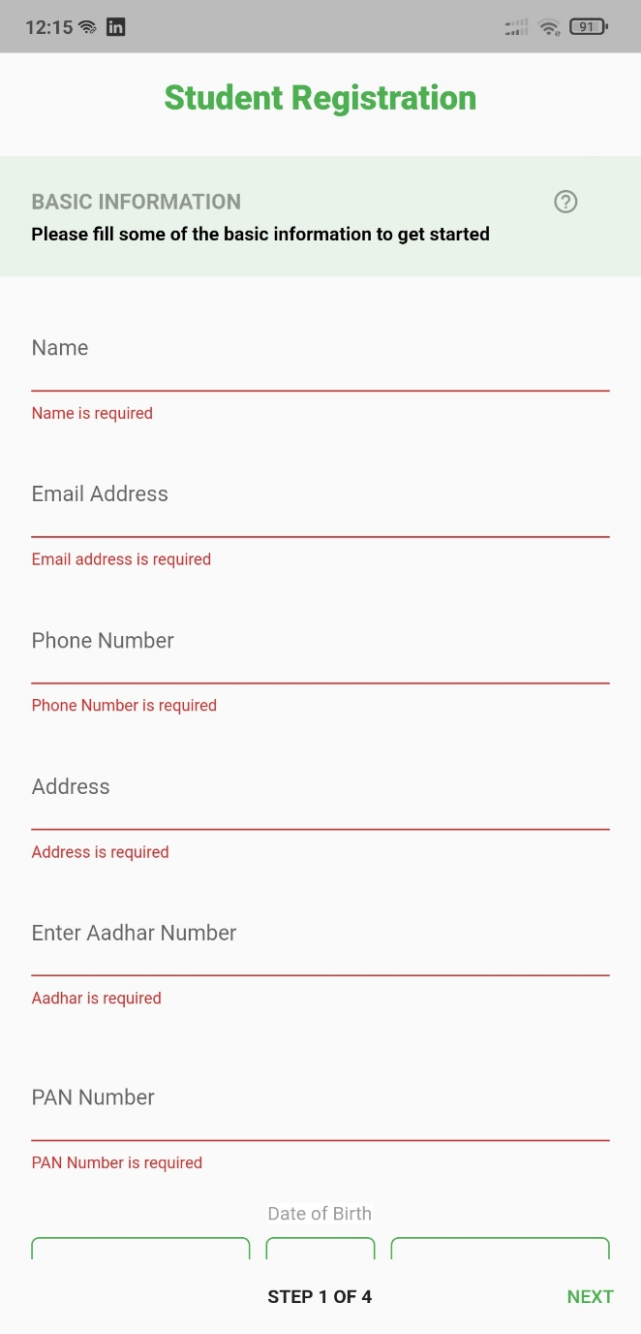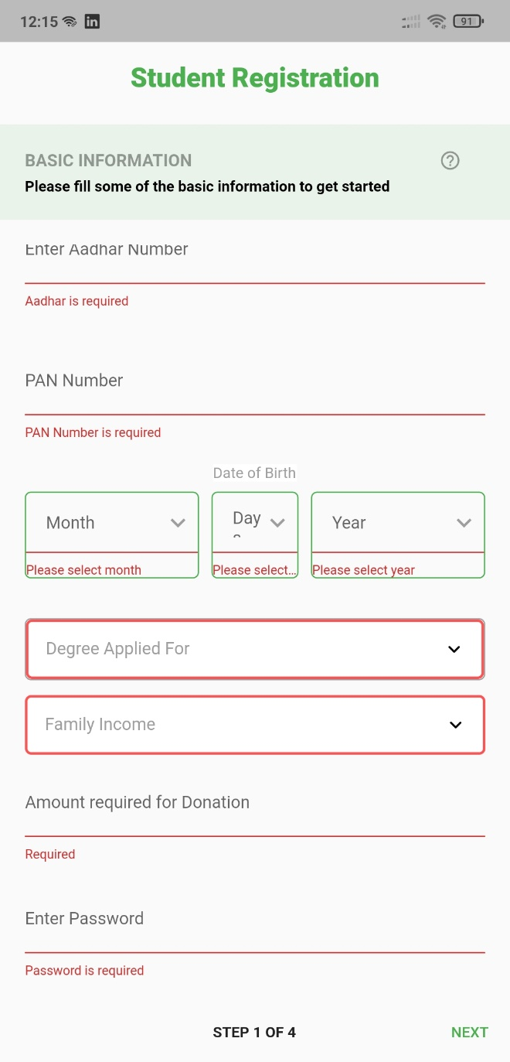

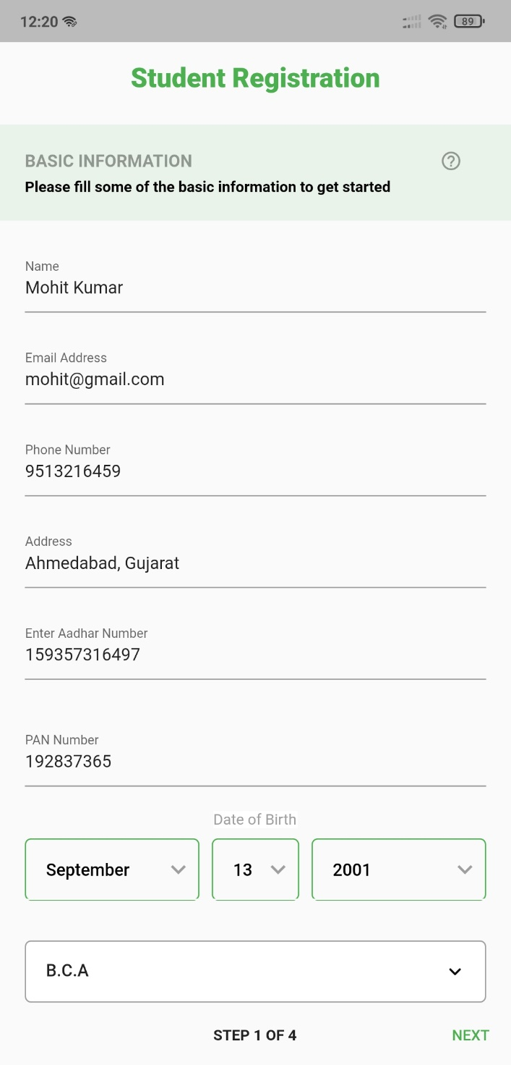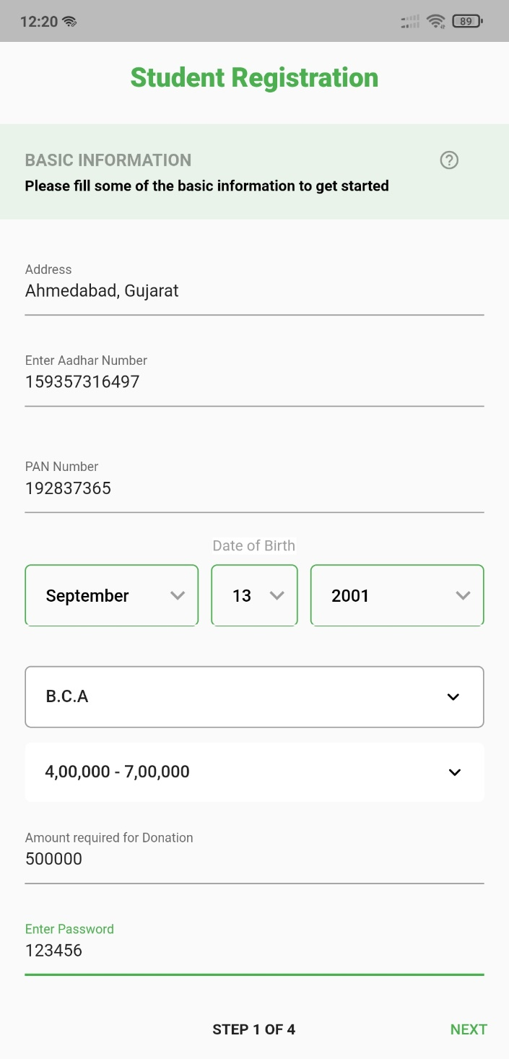

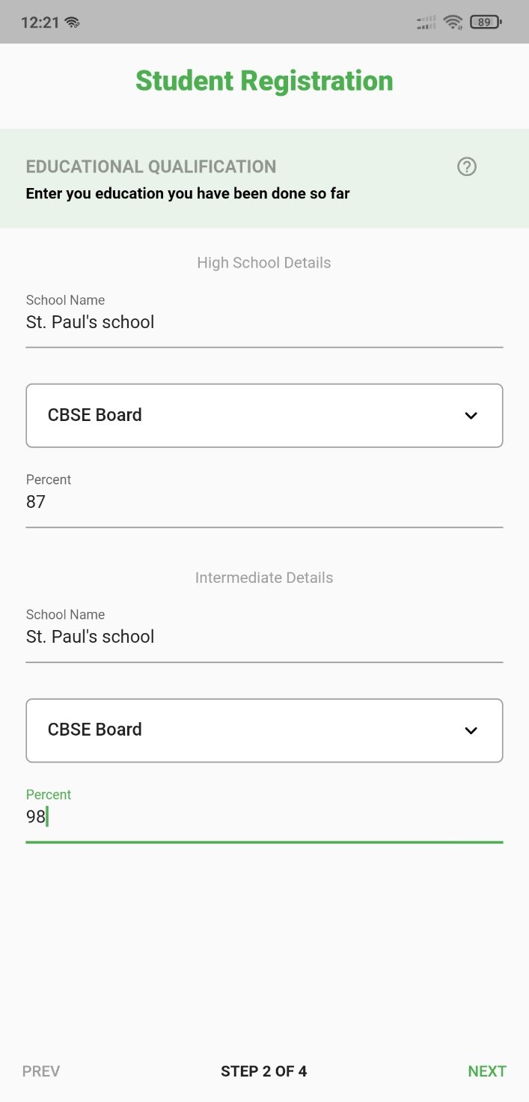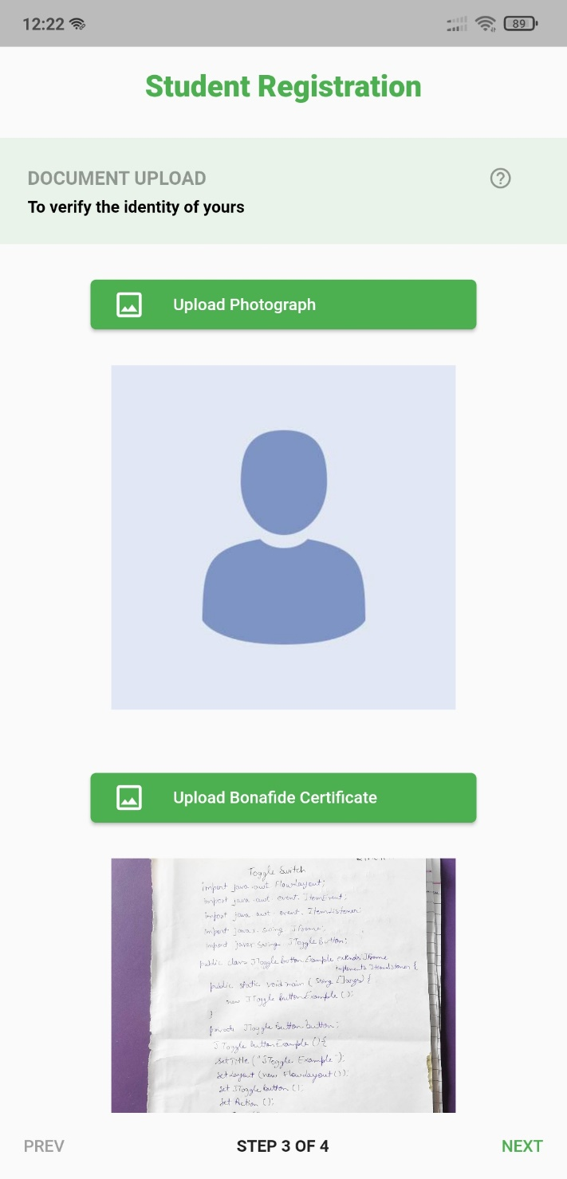

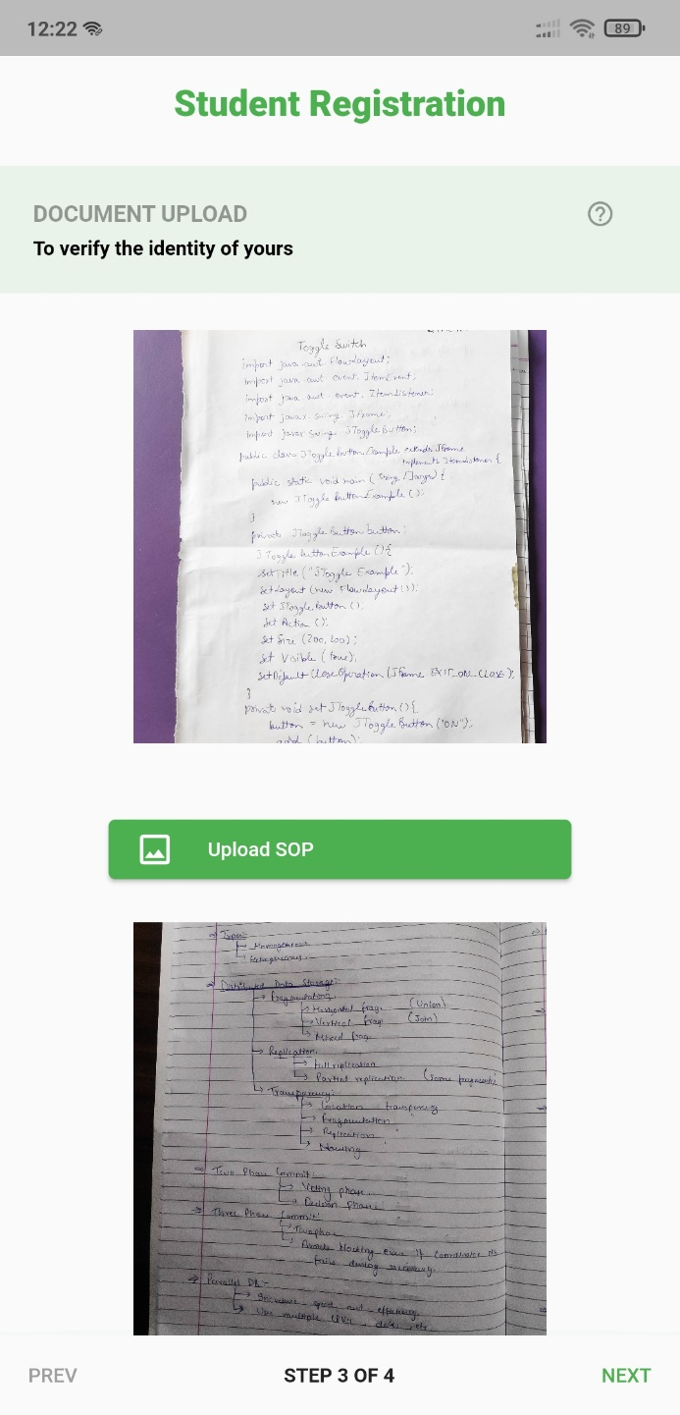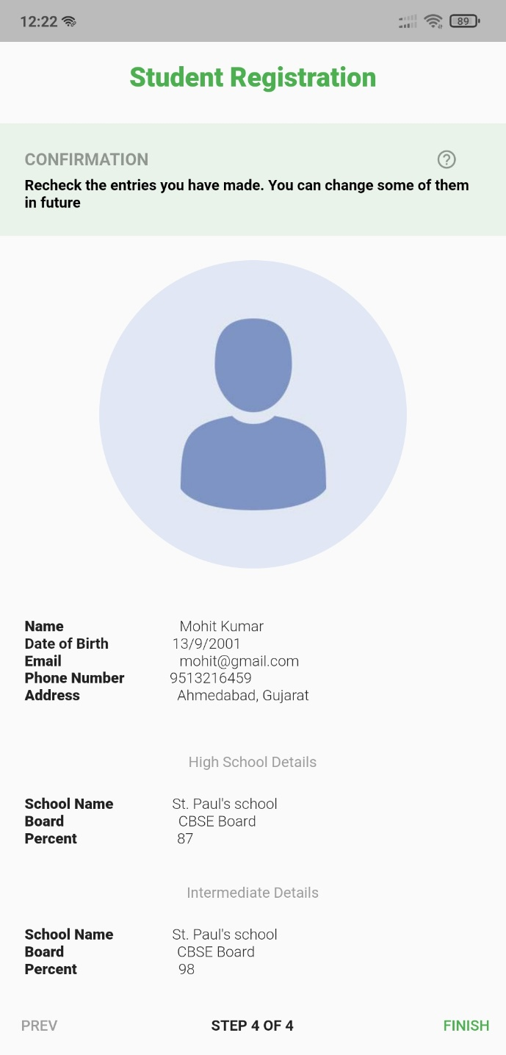

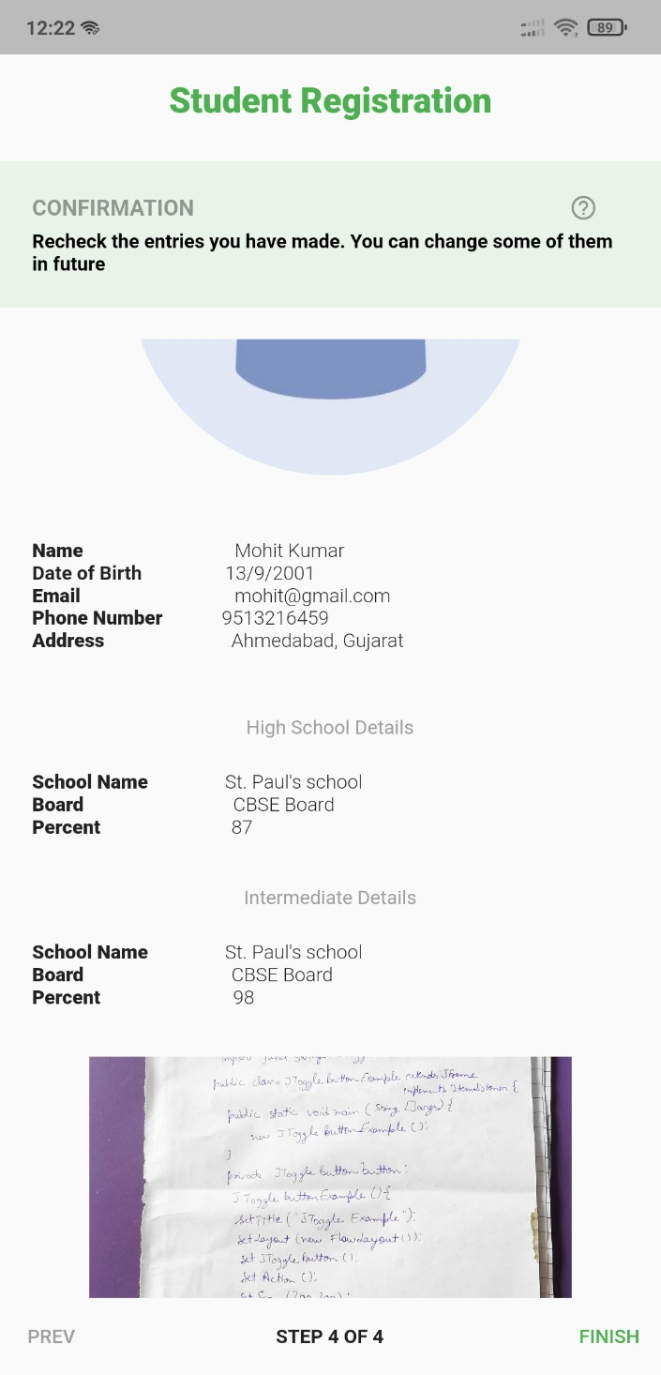

**Student Home Page:**

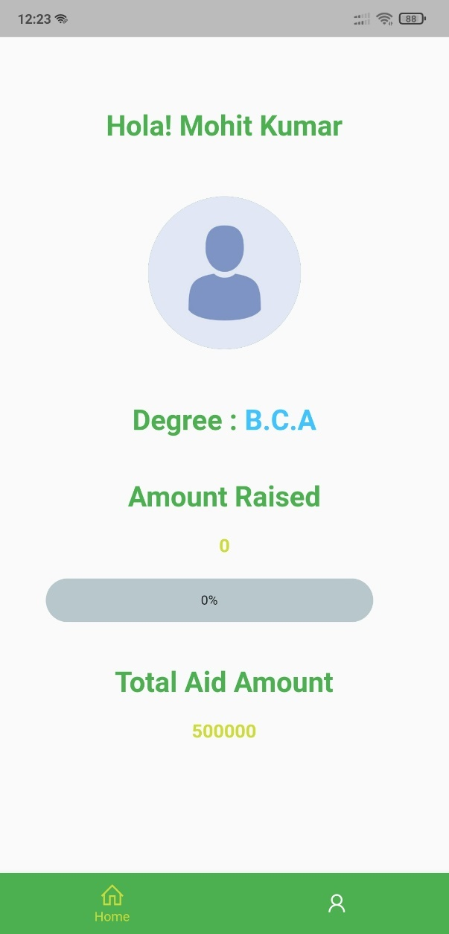 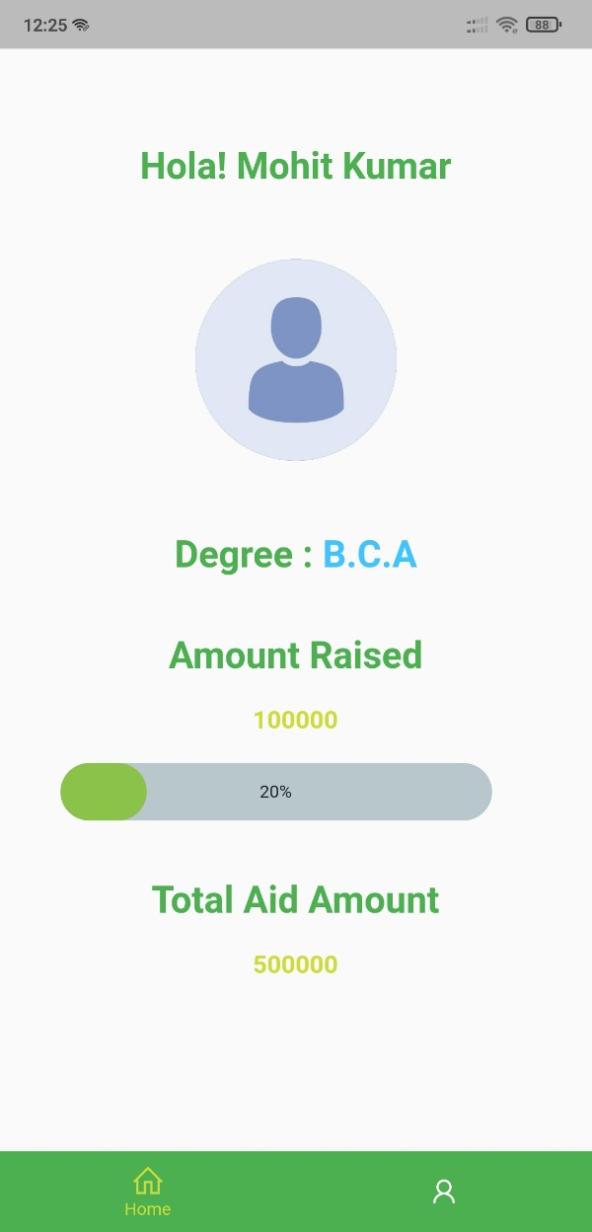

**Student Profile Page:**

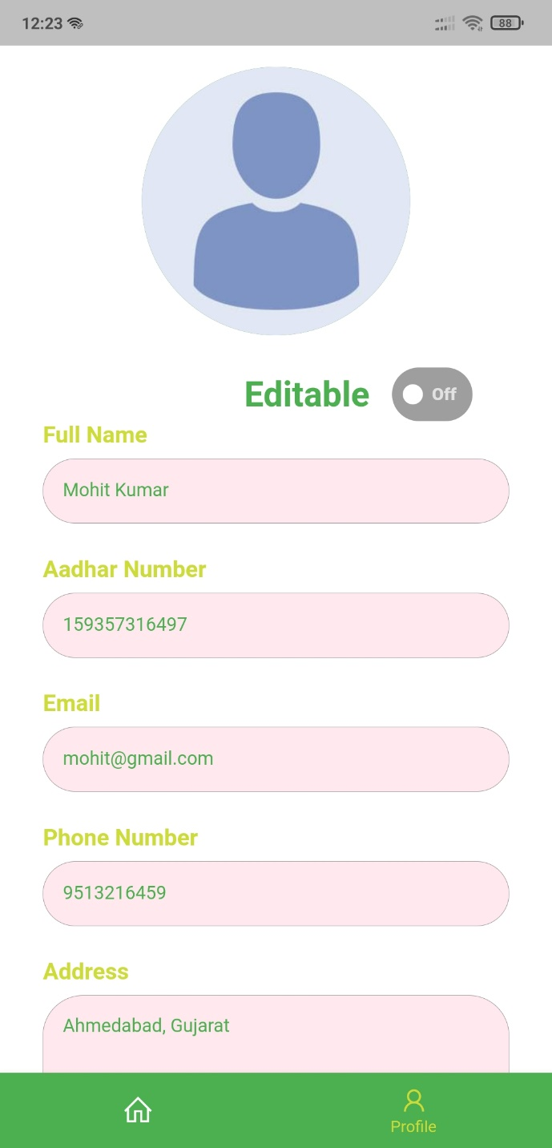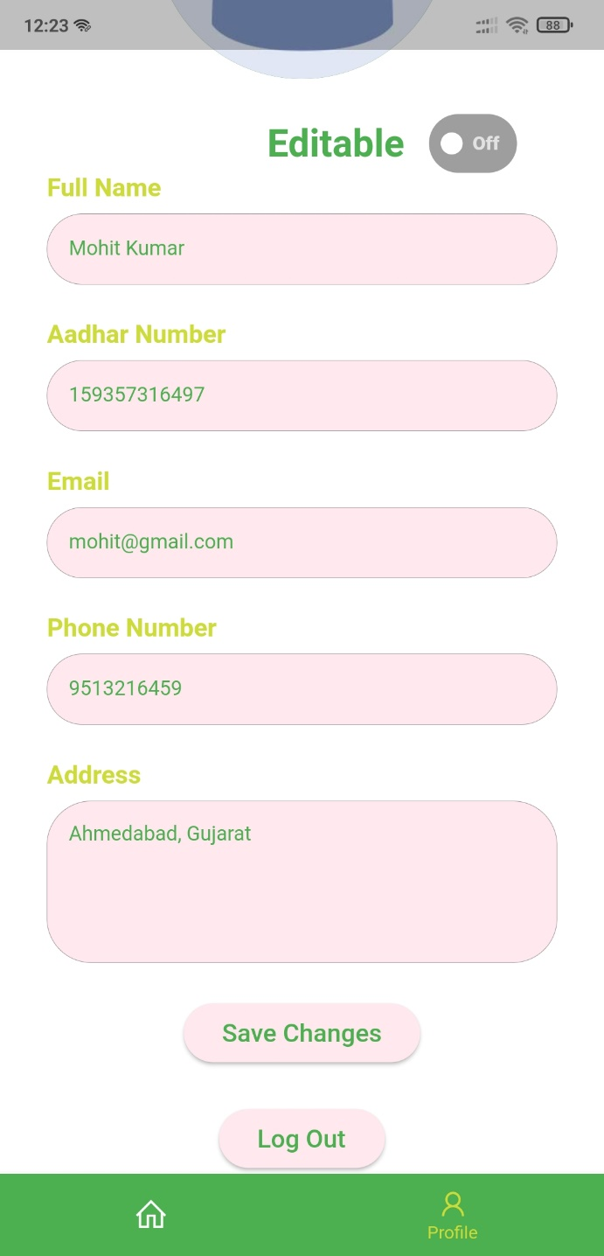

**Student Forgot Password**:







**PROJECT OUTCOME AND APPLICABILITY**

# Outline

Many children across the globe are unable to continue their studies because of their financial condition, and donation sites are flooded by the unauthenticated people which makes it difficult for the students to acquire donation for the studies. This is where Shiksha Anudan came into picture, Shiksha Anudan is across platform application which helps students to acquire funding to continue their education. It connects student to the donor who are willing to fund their education.

Significant project outcomes

#### Managing Donation

With our application, Shiksha Anudan, Student register himself/herself submit his/her document for the verification of the identity as well as educational background. After verification of the student, his/her profile will be created, and it will be available for the donation. Whenever the Student profile receive donation, his asked amount will be reduced after the successful transaction by the donor. Until student profile receives full asked amount his/her donation will be kept in his/her Shiksha Anudan profile, when the donation will be received in full whole amount will be transferred to student account.

#### Decision-Making Support

Shiksha Anudan include guidance in determining business decisions. This ties into cost reduction, as you can use data from software to **make informed decisions and carry out those decisions** directly within the software’s features.

This ensures that everything you do is based on real information and not just ‘a hunch’. Plus, you’ll be able to **share your insights with the team, brainstorm solutions, and generate reports** and records to ensure that things are done properly every step of the way.

# Project applicability on Real-world applications

#### Banks provide Education loan to the student who wants to continue education besides there financial condition but it’s repayment can be lot much harder because of the interest they keep on adding on the principal amount and after studies if their job cannot be that moratorium enough then they will keep on repaying their education loan for a very long amount of time. So, Shiksha Anudan came up with the solution to connect angel donor to the student, so that angel donor gets the financial merits which the government is providing to them, and students gets the fund to continue their studies without thinking of its repayment.

#### It helps you to create an incredible Donor experience

Creating an incredible and unique Donor experience is one of the important aspects of Shisha Anudan platform. There is a hassle-free registration process for the Donor, after the verification of the identity of the donor, he/she can move onto viewing profile of the students. Donor can also avail the facility to talk to the student. Donor can talk to the student via inbuilt messaging feature, which allows donor to know the student to whom he/she is donating. Donor can make payment via inbuilt payment gateway and can have digital record of it.

# Inference

Shiksha Anudan application provides a new way to financially challenged Student to continue their studies. Our application connects Students to a pool of Donors who are willing to fund studies of the students. Shiksha Anudan acts as mediocre between Donors and Students. On our platform, only genuine donors and students are available as both are verified by the administrator of the application which makes it fraud proof.

CONCLUSIONS AND RECOMMENDATION

**CONCLUSION**

The entire duration of this project has been a great learning experience for us. It has introduced us to the working of the real-life projects and taught us to face obstacles while developing them. By development of this cross-platform application, we here by conclude that Shiksha Anudan we have achieved our aim at following:

1. Building a platform where Student can ask for donation for their education. Which can save them into falling into the debt trap where they take bank loan to repay bank loan.
2. We believe that this platform has made it easier for the Donor to find genuine Student for the donation.
3. This platform has also made it easier for administrator to manage donation as well as profile of the Student and Donors.

We also hope to expand the scale of the project and make it ubiquitous by developing it for all digital platforms.

**BIBLIOGRAPHY**

##### Book References: -

1. Beginning App Development with Flutter

Publisher: Apress

Author: Rap Payne

1. Beginning Flutter: A Hands on Guide to App Development

Author: Marco L. Napoli

Publisher: Wiley

##### Website references: -

[www.tutorialspoint.com](http://www.tutorialspoint.com/)

[www. w3school.com](http://www.w3school.com/)

[www.stackoverflow.com](http://www.stackoverflow.com/)

[www.edrawsoft.com](http://www.edrawsoft.com)

[www.javatpoint.com](http://www.javatpoint.com/)

[www.lucidchart.com](http://www.lucidchart.com/)

[www.geeksforgeeks.org](http://www.geeksforgeeks.org/)

www.flutter.dev